Consult Toolbox

Software Version 1.9.0002

User Guide



November 2018

Department of Veterans Affairs

Office of Information and Technology (OIT)

Revision History

NOTE: The revision history cycle begins once changes or enhancements are requested after the document has been baselined.

| Date | Revision | Description | Author |
| --- | --- | --- | --- |
| 11/06/2018 | 9.2 | Updated the Other User Settings screen capture. Added the Preferred Client Cert: content to the document. | AbleVets |
| 08/28/2018 | 9.1 | Added Appendix A: Consult Factor Types and Definitions. | AbleVets |
| 06/15/2018 | 9.0 | Community Care SEOC functionality modified to utilize the SEOC DB, CAN Score functionality modified to utilize the CAN Score API when available, other functionality refined.  v1.9.02 | AbleVets |
| 06/04/2018 | 8.0 | Community Care SEOC interim functionality expanded to include additional SEOCs, other functionality refined.  V1.8.01 | AbleVets |
| 01/19/2018 | 7.0 | Community Care SEOC interim functionality added, other functionality refined v1.7.01 | AbleVets |
| 06/15/2017 | 6.0 | Community Care Functions section, Enable/Disable functionality refined v1.0.6051 | Charles S. Demosthenes, MD |
| 05/04/2017 | 5.1 | Enable and Disable functionality added v1.0.0505 | Charles S. Demosthenes, MD |
| 10/05/2016 | 5.0 | Rework of community care  Refinements of other modules v1.0.5 | Charles S. Demosthenes, MD |
| 04/05/2016 | 4.0 | Deployment Version v1.0.4 | Charles S. Demosthenes, MD |
| 01/21/2015 | 3.0 | Revisions to Discontinue consult v1.0.3 | Charles S. Demosthenes, MD |
| 01/05/2015 | 2.0 | Conversion to dialog boxes v1.0.2 | Charles S. Demosthenes, MD |
| 11/27/2015 | 1.0 | Initial Version v1.0 | Charles S. Demosthenes, MD |

Artifact Rationale

Per the Veteran-focused Integrated Process (VIP) Guide, the User’s Guide is required to be completed prior to Critical Decision Point #2 (CD2), with the expectation that it will be updated as needed. A User Guide is a technical communication document intended to give assistance to people using a particular system, such as VistA end users. It is usually written by a technical writer, although it can also be written by programmers, product or project managers, or other technical staff. Most user guides contain both a written guide and the associated images. In the case of computer applications, it is usual to include screenshots of the human-machine interfaces, and hardware manuals often include clear, simplified diagrams. The language used is matched to the intended audience, with jargon kept to a minimum or explained thoroughly. The User Guide is a mandatory, build-level document, and should be updated to reflect the contents of the most recently deployed build. The sections documented herein are required if applicable to your product.

Table of Contents

1. Introduction 1

1.1. Purpose 1

1.2. Document Orientation 1

1.2.1. Organization of the Manual 1

1.2.2. Assumptions 2

1.2.3. Coordination 2

1.2.4. Disclaimers 2

1.2.4.1. Software Disclaimer 2

1.2.4.2. Documentation Disclaimer 2

1.2.5. Documentation Conventions 3

1.2.6. References and Resources 3

1.3. National Service Desk and Organizational Contacts 3

2. System Summary 3

2.1. System Configuration 3

2.2. Data Flows 3

2.3. User Access Levels 3

2.4. Continuity of Operation 4

3. Getting Started 4

3.1. Accessing Consult Toolbox 4

3.1.1. Enabling Consult Toolbox 4

3.1.2. Setting Consult Toolbox Preferences 5

3.2. System Menu 10

3.2.1. Receive 10

3.2.2. Discontinue 13

3.2.3. Forward 16

3.2.4. Add Comment: Scheduler Functions 17

3.2.5. Add Comment: Community Care Functions 21

3.2.6. Add Comment: Clinical Review Options 45

3.2.7. Significant Findings: Community Care Action Required 47

3.2.8. Administrative Closure 48

4. Using the Software 48

4.1. Receiving Consult Activities 49

4.2. Discontinuing Consult 51

4.2.1. Discontinuing In-house Consult 51

4.2.2. Discontinuing Community Care Consult 52

4.3. Forwarding Consult 54

4.4. Adding Comment to Consult 54

4.4.1. Scheduling Functions 55

4.4.1.1. Scheduling Calls and Letters 55

4.4.1.2. Scheduling and Rescheduling Efforts 57

4.4.1.3. Community Care Eligibility 59

4.4.2. Community Care Functions 62

4.4.2.1. MSA Eligibility Verification 63

4.4.2.1.1. Community Care (CC) Document Administrative Screening 64

4.4.2.2. Consult Review 68

4.4.2.2.1. Clinical Triage 69

4.4.2.3. Authorization 74

4.4.2.4. DoD 76

4.4.2.5. MSA Pt Contacts 77

4.4.2.6. Appt Tracking 79

4.4.2.7. Secondary Authorization Request 80

4.4.2.8. Consult Completion 82

4.4.2.9. Care Coordination 83

4.4.3. Setting Clinical Review Options 85

4.5. Significant Findings – Community Care Action Needed Notation 87

4.6. Administratively Close Consult 88

5. Troubleshooting 89

5.1. National Service Desk and Organizational Contacts 89

6. Acronyms and Abbreviations 89

A. Appendix A: Consult Factor Types and Definitions 90

B. Appendix B: Community Care Appointment Tracking – VA Scheduling Appointment 98

Table of Figures

Figure 1: Enable Consult Toolbox Menu Option 4

Figure 2: About Consult Toolbox 5

Figure 3: Consult Toolbox Preferences and Settings 6

Figure 4: Receive Consult Options 6

Figure 5: Add Comment to Consult Options 7

Figure 6: Discontinue Consult Options 8

Figure 7: Other User Settings Tab 8

Figure 8: Receive Routine Consult Options Window 10

Figure 9: Low Risk Clinics Options 12

Figure 10: Extra Scheduling Effort Drop-Down Menu Options 12

Figure 11: General Discontinuation Comments Tab 13

Figure 12: Other Reason Menu Options 14

Figure 13: Community Care Discontinuation Comments Tab 14

Figure 14: Forward to Community Care Options Tab 16

Figure 15: Calls and Letters Tab 17

Figure 16: Sched/Rescheduling Efforts Tab 19

Figure 17: Community Care Eligibility Tab 20

Figure 18: Community Care Functions Window: MSA Elig. Verification Tab 21

Figure 19: Specific Choice Eligibility Verified Menu Options 22

Figure 20: Administrative Screening 23

Figure 21: Clinical Care Coordination Assignment 25

Figure 22: Consult Review Tab 26

Figure 23: Request Approved (Select CC Program) Menu Options 27

Figure 24: Guideline Review Method Menu Options 28

Figure 25: Authorization Tab 28

Figure 26: SEOC Menu Options 29

Figure 27: DoD Tab 30

Figure 28: DoD Urgency Menu Options 31

Figure 29: Disposition Menu Options 31

Figure 30: Unable to Schedule (reason): Menu Options 31

Figure 31: DoD Consult Present Menu Options 32

Figure 32: Exception Disposition 32

Figure 33: MSA Pt Contacts 33

Figure 34: Search by Provider Tab 35

Figure 35: Search by Institution Tab 36

Figure 36: Appt Tracking Tab 37

Figure 37: Appointment Date Calendar View 38

Figure 38: SAR Tab 41

Figure 39: Consult Completion Tab 42

Figure 40: Records rec’d, forwarded to medical records Menu Options 43

Figure 41: Care Coordination Tab 44

Figure 42: Clinical Review Options 45

Figure 43: Significant Findings Update 47

Figure 44: Administratively Close 48

Figure 45: Receive Routine Consult Options Window 50

Figure 46: General Discontinuation Comments 52

Figure 47: Comm Care Discontinuation Comments 53

Figure 48: Forward to Community Care Options 54

Figure 49: Add Comment to Consult Dialog Box 55

Figure 50: Calls and Letters Tab 56

Figure 51: Viewing Consult History 57

Figure 52: Add Comment to Consult Dialog Box 58

Figure 53: Calls and Letters Tab 58

Figure 54: Sched/Rescheduling Efforts Tab 59

Figure 55: Add Comment to Consult Dialog Box 60

Figure 56: Calls and Letters Tab 61

Figure 57: Community Care Eligibility Tab 62

Figure 58: Add Comment to Consult Dialog Box 63

Figure 59: Community Care Functions Window: MSA Elig. Verification Tab 64

Figure 60: MSA Elig. Verification Tab: Document Administrative Screening Section 65

Figure 61: Administrative Screening (for use by community care staff only) Window 66

Figure 62: Name of scheduling staff member you will alert: Field 67

Figure 63: Document Administrative Screening Populated 68

Figure 64: Add Comment to Consult Dialog Box 68

Figure 65: Consult Review Tab 69

Figure 66: Add Comment to Consult Dialog Box 70

Figure 67: Consult Review Tab 71

Figure 68: Clinical Triage for Care Coordination 72

Figure 69: New Clinical Triage Coordination Level 73

Figure 70: Comment Added to Consult 74

Figure 71: Add Comment to Consult Dialog Box 74

Figure 72: Authorization Tab 75

Figure 73: Add Comment to Consult Dialog Box 76

Figure 74: DoD Tab 77

Figure 75: Add Comment to Consult Dialog Box 78

Figure 76: MSA Pt Contacts Tab 78

Figure 77: Add Comment to Consult Dialog Box 79

Figure 78: Appt Tracking Tab 80

Figure 79: Add Comment to Consult Dialog Box 81

Figure 80: SAR Tab 81

Figure 81: Add Comment to Consult Dialog Box 82

Figure 82: Consult Completion Tab 83

Figure 83: Add Comment to Consult Dialog Box 84

Figure 84: Care Coordination Tab 84

Figure 85: Add Comment to Consult Dialog Box 85

Figure 86: Clinical Review Options 86

Figure 87: Significant Findings Update 87

Figure 88: Administratively Close Dialog Box 88

# Introduction

The Consult Toolbox software was created by the Atlanta Department of Veterans Affairs (VA) Medical Center in response to a need to manage the process of consult management. During the life of a consult, there are steps of actions to be taken, and there is a need to be able to track these steps at an individual patient level. Additionally, there is a need to be able to understand the overall status of consult management at a macro level, and identify specific services needing attention or resources. Without opening and reading a patient medical record, it is difficult to identify which Veterans have had which scheduling steps completed.

This software does several things. First, it makes it very easy for staff to document actions completed quickly and consistently. Second, it uses consistent verbiage to document these steps. Third, it eliminates the need to take a second action or make a separate entry to track scheduling steps. Fourth, this consistent verbiage allows software analysis of records without needing to have software changes to Veterans Health Information Systems and Technology Architecture (VistA) or Computerized Patient Record System (CPRS).

A separate process using Corporate Data Warehouse (CDW) queries and reports allows creation of views showing such things as Veterans who have not had first call, second call, scheduling letter sent or how much time has passed between these events.

Together, these allow tracking and managing consults without the need to keep a separate list or other workflow to know which consults need attention.

## Purpose

The purpose of this document is to provide instruction for utilizing the Consult Toolbox to standardize and streamline consult management for Community Care.

## Document Orientation

The *One Consult Toolbox v1.9.0002 User Guide* will provide explanations of each screen and of all user interface options within the context of an easy to understand demonstration data scenario.

This document is also designed to provide the user with screen-by-screen “how to” information on the usage of Consult Toolbox.

### Organization of the Manual

**Section 1: Introduction**

The Introduction section provides the purpose of this manual, an overview of the Consult Toolbox software, an overview of the software used, project references, contact information for the user to seek additional information, and an acronyms and abbreviations list for this manual.

**Section 2: System Summary**

The System Summary section provides a graphical representation of the equipment, communication, and networks used by the system, user access levels, how the software will be accessed, and contingencies and alternative modes of operation.

**Section 3: Getting Started**

Information for the Getting Started section provides a general walk-through of the system from initiation through exit, enabling the user to understand the sequence and flow of the system.

**Section 4: Using the Software**

This section gives the user the “how to” information to use Consult Toolbox, including many step-by-step procedures.

**Section 5: Troubleshooting**

This section provides troubleshooting for the Consult Toolbox user.

**Section 6: Acronyms and Abbreviations**

This section provides a list of acronyms and abbreviations found in this document.

### Assumptions

The user must have login credentials for CPRS.

### Coordination

N/A

### Disclaimers

#### Software Disclaimer

This software was developed at the Department of Veterans Affairs (VA) by employees of the Federal Government in the course of their official duties. Pursuant to title 17 Section 105 of the United States Code this software is not subject to copyright protection and is in the public domain. VA assumes no responsibility whatsoever for its use by other parties, and makes no guarantees, expressed or implied, about its quality, reliability, or any other characteristic. We would appreciate acknowledgement if the software is used. This software can be redistributed and/or modified freely provided that any derivative works bear some notice that they are derived from it, and any modified versions bear some notice that they have been modified.

#### Documentation Disclaimer

The appearance of external hyperlink references in this manual does not constitute endorsement by the Department of Veterans Affairs (VA) of this Web site or the information, products, or services contained therein. The VA does not exercise any editorial control over the information you may find at these locations. Such links are provided and are consistent with the stated purpose of the VA.

### Documentation Conventions

This manual uses several methods to highlight different aspects of the material.

Table . Documentation Symbols and Descriptions

| Symbol | Description |
| --- | --- |
| Triangle with an exclamation point (!) inside to indicate caution for the reader to take special notice of critical information. | **CAUTION:** Used to caution the reader to take special notice of critical information. |

1. Notes are used to inform the reader of general information including references to additional reading material.

### References and Resources

Readers who wish to learn more about CPRS and Consult Toolbox should consult the following:

* CPRS: Consult/Request Tracking in the VDL: <https://www.va.gov/vdl/application.asp?appid=62>
* <http://www.vehu.va.gov/vehu/Resources.cfm>

## National Service Desk and Organizational Contacts

For issues related to the Consult Toolbox that cannot be resolved by this manual or the site administrator, please contact the National Service Desk at 855-NSD-HELP (673-4357).

# System Summary

## System Configuration

The Consult Toolbox software installs at the Windows level and resides in the system tray. It watches keyboard and mouse activity, and comes to life when certain conditions occur. The first is it only activates when the currently active windows title **Add Comment to Consult**, **Forward Consult**, **Discontinue Consult**, **Administratively Complete**, **Receive Consult**, **Update** **Significant Findings**, or WIN+V. Otherwise it does nothing.

The second is when the user initiates a trigger event when either of these windows have the focus, then depending on the open window a menu appears for the user to select the appropriate action, then the software inserts the appropriate text into the comment box.

The defined trigger is a right mouse click in the supported CPRS consult actions.

## Data Flows

N/A

## User Access Levels

N/A

## Continuity of Operation

N/A

# Getting Started

This section provides a general walkthrough of Consult Toolbox from initiation through exit.

## Accessing Consult Toolbox

1. If you are unable to access/use Consult Toolbox, see the Troubleshooting section in this document or contact the National Service Desk at 855-NSD-HELP (673-4357).

### Enabling Consult Toolbox

1. Before enabling Consult Toolbox in CPRS, you will need to run the ConsultToolbox.exe file. The file can be found in the following location: <C:\Program Files\ConsultToolBox\ConsultToolbox.exe>.

Consult Toolbox is part of the CPRS system which requires both a user name and password. On the first use, Consult Toolbox will be disabled until you enable through the CPRS Tools menu. Once enabled, you’ll want to set your preferences.

The Consult Toolbox should be enabled on the applicable computer (this only needs to be done once on a given computer for each person).

When installed on the PC, it will be installed on the workstation as an installed program, but it will need to be enabled. This should be set up on the CPRS Tools menu. Below is an example of how it might, look, but depending on how the station Clinical Application Coordinators (CAC) set-up the tool, the enable link may be in some other location on the tool bar, so each station may look different.

Figure : Enable Consult Toolbox Menu Option

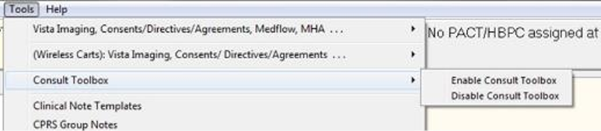

Selecting **Enable Consult Toolbox** will activate the Toolbox so it will be open automatically each time Windows is opened. It only needs to be done once for a given PC, and enabled; the Consult Toolbox will be active each time you log into this computer.

When changing computers, the user will need to enable it on the new computer. It will remain enabled from then on, until it is disabled. In the event the Consult Toolbox seems to not be working correctly, enable it again and it will reset.

### Setting Consult Toolbox Preferences

The Settings functionality within the Consult Toolbox provides any user the ability to select their default features upon opening the Toolbox based on their roles and responsibilities.

To update your Consult Toolbox settings, follow the steps listed below:

1. Press the Windows + V key. Once these keys are pressed, the **About Consult Toolbox** dialog box opens.

Figure : About Consult Toolbox

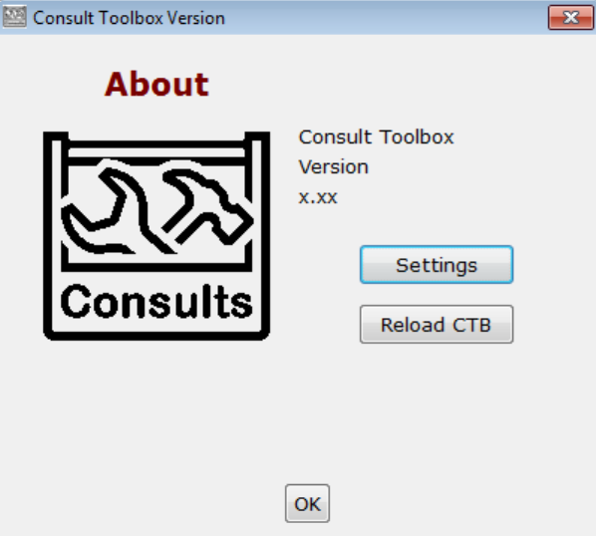

1. Click **Settings** to set the preferences. The **Consult Toolbox Preferences and Settings** window opens.
2. Clicking **OK** will close the dialog box and otherwise do nothing. The **Reload CTB** resets the Consult Toolbox and can also be used to recover from a technical glitch.

Figure : Consult Toolbox Preferences and Settings

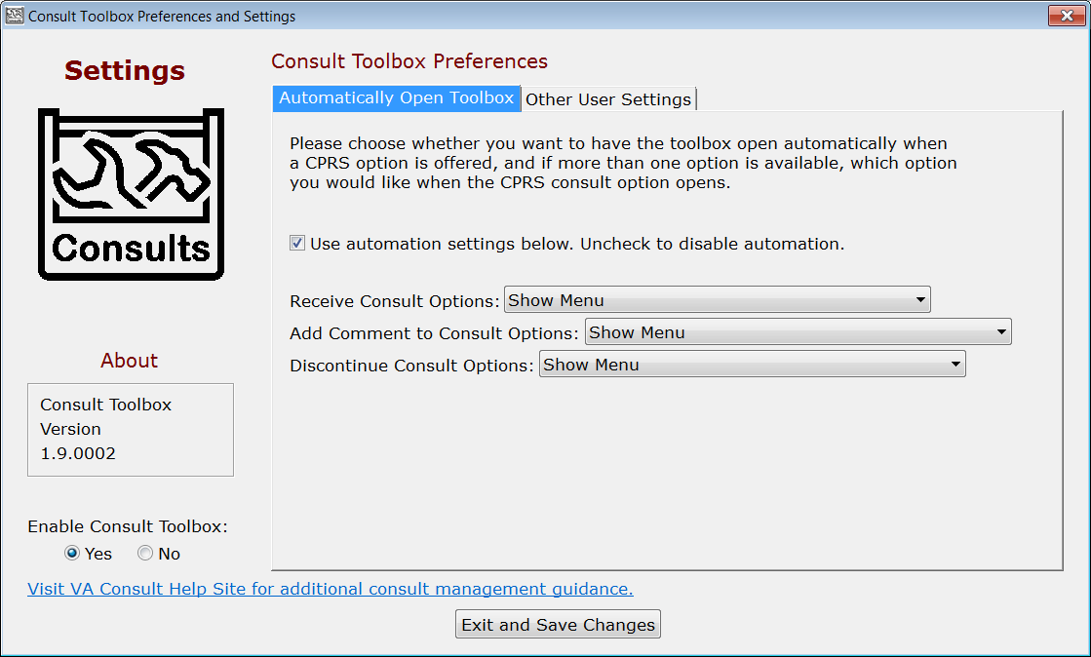

1. The **Consult Toolbox Preferences and Settings** window also displays the Consult Toolbox Version number.
2. Select the **Automatically Open Toolbox** tab.
3. From the **Enable Consult Toolbox** section, select **Yes** or **No**.

* **Yes –** this makes the Consult Toolbox function. By enabling it, a link to the Consult Toolbox is placed in the Windows Start Up folder, so the consult toolbox is active each time you log into this PC.
* **No** – this removes any link from the Startup Menu, and turns off the Consult Toolbox. After selecting this option, the Consult Toolbox will no longer function. It will need to be enabled once again from the CPRS Tools menu.

1. Select the **Use automation settings below**. check box to automate settings, otherwise the automation functionality will be disabled.
2. From the **Receive Consult Options:** drop-down menu, select the preferred receive consult option.

Figure : Receive Consult Options

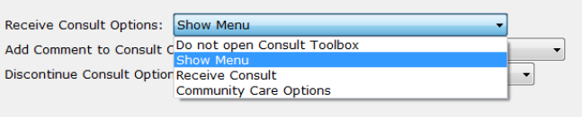

* **Do not open Consult Toolbox:** Nothing will happen when the receive consult box opens.
* **Show menu:** As soon as the Receive Consult box opens, the shortcut menu will show itself for the user to select. The user may select Receive Consult, or select something else. Clicking in the white space of the box, will cause the shortcut menu to disappear.
* **Receive Consult:** As soon as the Receive Consult box appears, the Receive Consult screen for the Consult Toolbox will also appear.
* **Community Care Options:** As soon as the Receive Consult box appears, the Community Care screen for the Consult Toolbox will also appear. Note, this is the same screen appears under Community Care Options on the **Add Comment to Consult** CPRS box.

1. From the **Add Comment to Consult Options:** drop-down menu, select the preferred add comment to consult option.

Figure : Add Comment to Consult Options

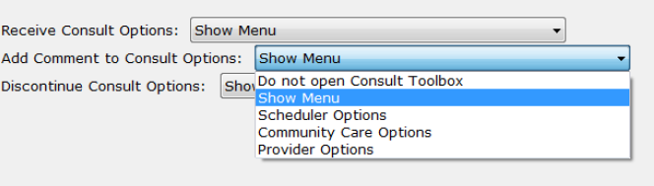

* **Do not open Consult Toolbox:** Nothing will happen when the CPRS add comment box opens.
* **Show menu:** As soon as the Add Comment to Consult box opens, the shortcut menu will show itself for the user to select. The user may select an option, or doing something else, including clicking in the white space of the box, will cause the shortcut menu to disappear.
* **Scheduler Options:** As soon as the Add Comment to Consult pop-up box appears, the Consult Toolbox screen for in-house VA schedulers will also appear.
* **Community Care Options:** As soon as the Add Comment to Consult pop-up box appears, the Community Care screen for the Consult Toolbox will also appear. This is the same screen that appears under Community Care Options on the **Receive Consult** CPRS box.
* **Provider Options:** As soon as the Add Comment to Consult dialog box opens, the provider review screen will appear.

1. For VA in-house consult schedulers, the recommended setting is **Scheduler Options**. For Community Care staff (clinical and administrative), the recommended setting is **Community Care Options** and for in-house clinicians, the recommended setting is **Provider Options**.
2. From the **Discontinue Consult Options:** drop-down menu, select the preferred discontinue consult option.

Figure : Discontinue Consult Options

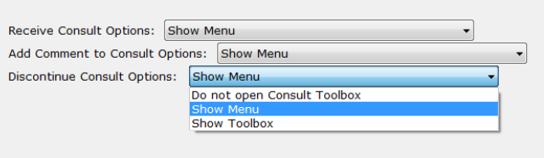

* **Do not open Consult Toolbox:** Nothing will happen when the CPRS discontinue box opens.
* **Show menu:** As soon as the Discontinue Consult pop-up box opens, the shortcut menu will show itself for the user to select. The user may select an option, or doing something else, including clicking in the white space of the box, will cause the shortcut menu to disappear.
* **Show Toolbox:** As soon Discontinue Consult pop-up box opens, the Consult Toolbox discontinue consult screen also appears.

1. Select the **Other User Settings** tab.

Figure : Other User Settings Tab

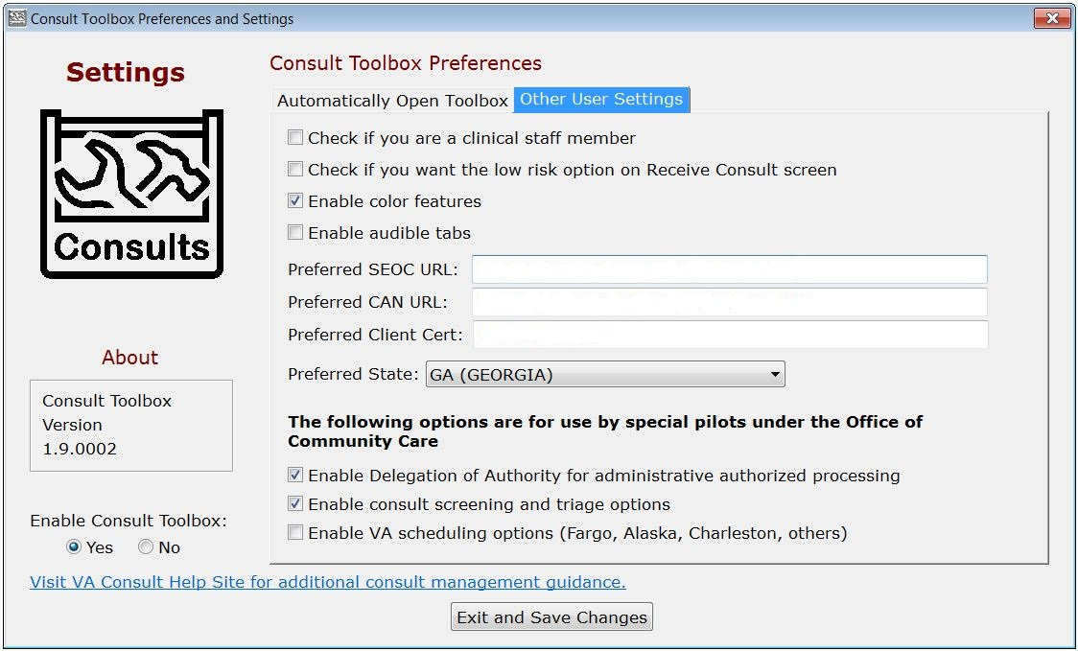

1. Select the check boxes for the preferred settings.

* **Check if you are a clinical staff member** – This is pertinent only under the Community Care screen. If the user can make clinical assessments or decisions in the management of community care, select yes for this option. Staff selecting yes are typically nurses and licensed practitioners.
* **Check if you want the low risk option on Receive Consult screen –** VHA has defined low risk clinics nationally to include: physical therapy, occupational therapy, kinesiotherapy, acupuncture, smoking clinic, MOVE clinic, massage therapy, chiropractic care and erectile dysfunction clinic. A full list of low risk clinics can be found in the VHA Consult SOP. As soon as the Receive Consult box appears, the Receive Consult screen for the Consult Toolbox for low risk clinics will also appear. Note that to use this option, a clinic must be approved as a low risk clinic by the facility consult management (Committee or COS designee). The VHA Consult SOP can be located in the following link: https://vaww.vha.vaco.portal.va.gov/sites/DUSHOM/10NA/ACAO/ConsultManagement/[Policy/Forms/AllItems.aspx?RootFolder=%2Fsites%2FDUSHOM%2F10NA%2FACAO%2FconsultManagement%2Fpolicy%2Fconsult%20Management%20SOP&FolderCTID=0x01200045E19B25BB3B7C4DA29DDBB4E414F0B6&View={B401205F-3C4C-499B-B416-8689D576B245}](https://vaww.vha.vaco.portal.va.gov/sites/DUSHOM/10NA/ACAO/ConsultManagement/Policy/Forms/AllItems.aspx?RootFolder=%2Fsites%2FDUSHOM%2F10NA%2FACAO%2FConsultManagement%2FPolicy%2FConsult%20Management%20SOP&amp;FolderCTID=0x01200045E19B25BB3B7C4DA29DDBB4E414F0B6&amp;View=%7bB401205F-3C4C-499B-B416-8689D576B245%7d).
* **Enable color features** – If checked, certain screens will have some headings and selected tabs with color highlights instead of being in black, white and grey. The screen image above shows how the tabs look with color highlight off.
* **Enable audible tabs** – Reads aloud the community care comments panel tab name.
* **Preferred SEOC URL:** - The Preferred SEOC URL should only be changed if directed by support personnel. The URL and certificate name can be changed by support to suit the execution environment.
* **Preferred CAN URL:** - The Preferred CAN URL should only be changed if directed by support personnel. The URL and certificate name can be changed by support to suit the execution environment.
* **Preferred Client Cert:** - The name of the internet browser certificate that will be used to contact the CAN score server online.
* **Preferred State**: Enter the state you typically use for community care providers. This will be the default setting any time you look up a provider for community care. You can always change it.

1. From the **The following options are for use by special pilots under the Office of Community Care** section, select preferred options.

* **Enable Delegation of Authority for administrative authorized processing –** The Delegation of Authority is an action taken by the Chief of Staff to delegate clinical review authority for services that are requested through a community care consult. If this process was implemented in your facility, check this box.
* **Enable consult screening and triage options** – At the time of this version, local community care staff will have the ability to assign care coordination levels based on a Veterans complexity of needs. Check this box to begin using this functionality.
* **Enable VA scheduling options (Fargo, Alaska, Charleston, others)** – At this time Fargo, Alaska and perhaps other facilities are piloting community care scheduling by VA staff, instead of having the vendor (e.g. HealthNet or TriWest) take responsibility for scheduling. If your facility is doing the community care scheduling instead of the vendor, check this box.

1. These options are applicable only for those select VAMCs that have completed a scheduling and care coordination contract modification with Health Net or TriWest.
2. Click **Exit and Save Changes** to save the selected settings for future work sessions.

## System Menu

### Receive

Figure : Receive Routine Consult Options Window

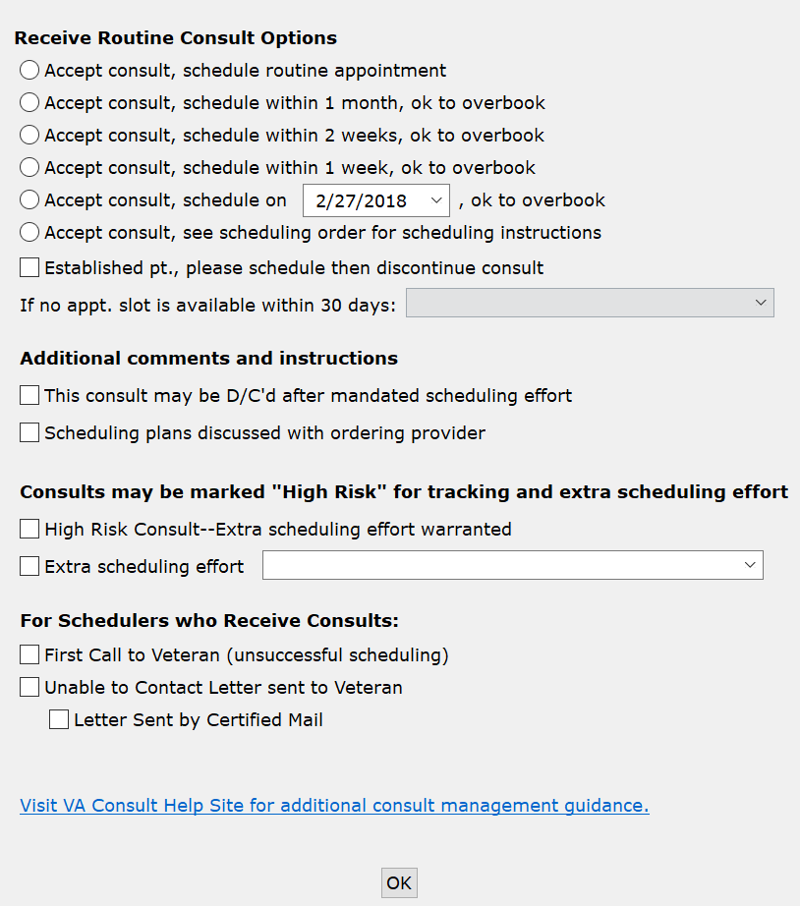

* **Receive Routine Consult Options** section
* **Accept consult, schedule routine appointment** – Accept consult, schedule within one month, ok to overbook—the reviewing provider has determined that the Veteran’s medical condition warrants them being seen within one month and should be overbooked if needed to accomplish that effect.
* **Accept consult, schedule within 1 month (OK to overbook)** – Accept consult schedule within two weeks, ok to overbook—the reviewing provider has determined that the Veteran’s medical condition warrants them being seen within two weeks and should be overbooked if needed to accomplish that effect.
* **Accept consult, schedule within 2 weeks, (OK to overbook)** – Accept consult schedule within one week ok to overbook—the reviewing provider has determined that the Veteran’s medical condition warrants them being seen within one week and should be overbooked if needed to accomplish that effect. If less than one week or immediate, the provider may add additional instructions, or speak directly with the scheduler if truly urgent.
* **Accept consult, schedule within 1 week, (OK to overbook)** – Accept consult schedule on a specific date—this allows the provider to specify the date to see the Veteran.
* **Accept consult, schedule on MM/DD/YYYY, (OK to overbook)** – Accept consult see scheduling order for scheduling instructions—this selection applies if the clinic or service provider prefers to convey scheduling instructions via a CPRS order.
* **Accept consult; see scheduling order for scheduling instructions –** this selection applies if the clinic or service provider prefers to convey scheduling instructions via CPRS order.
* **Established pt., please schedule then discontinue consult** – this selection applies if a consult is received for an established patient. Once the consult is received, it is sent to the scheduler to make the appointment. Once the appointment is made, the consult can be discontinued.
* **If no appt. slot is available within 30 days:**
  + - **Forward to Community Care Office**
    - **Discuss with Clinical Staff**
* **Additional comments and instructions** section
* **This consult may be D/C’d after mandated scheduling effort**—this option allows the reviewing provider to determine at the time of acceptance that if the staff is unable to get the appointment scheduled, or if the Veteran cancels or no-shows twice, then the consult can be discontinued by the scheduler without having another clinical review. The consult is returned to the ordering provider to take whatever action deemed appropriate.

1. The **This consult may be discontinued d/c’d after 1 missed appointment (approved low risk clinic)** check box described below is only visable when enabled in the Consult Toolbox Settings.

* **This consult may be discontinued d/c’d after 1 missed appointment (approved low risk clinic)** – An additional option for low risk clinics exists for discontinuation after one missed appointment. This screen auto populates from settings described above.

Figure : Low Risk Clinics Options

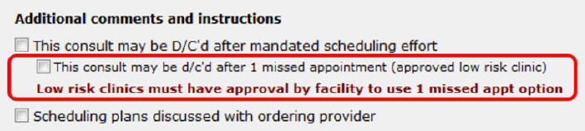

* **Scheduling plans discussed with ordering provider**—this selection is simply for the convenience of the reviewing provider to document the instance where they have discussed the case with the ordering provider. This allows them to easily document that conversation took place. It doesn’t have any significant ramifications with respect to consult processing.
* **Consults should be marked “High Risk” for track and extra scheduling effort** section
* **High Risk Consult-Extra scheduling effort warranted** – this will flag this consult as having a medically high-risk condition that warrants additional calls to the Veteran beyond the mandated minimum necessary effort. It also allows the receiving service to flag certain consults for closer follow up when the Veteran fails to keep appointments. Each service may define what high risk means to them. This is simply a way of segregating higher risk consults from the rest and notifying the staff to expend additional effort.
* **Extra scheduling effort** – allows the reviewer to specify what additional effort they would like. In addition to the selection of options, the user may type in other instructions.

Figure : Extra Scheduling Effort Drop-Down Menu Options

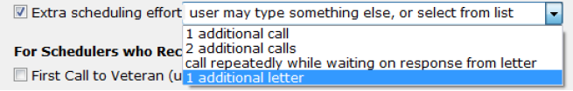

* **For Schedulers Who Receives Consults** section,
* **First call to Veteran (unsuccessful scheduling)** – This option supports recording calls to Veteran that were successful.
* **Unable to Contact letter sent to Veteran** – use this selection when a letter is sent to the Veteran indicating that the clinic has tried to reach the Veteran to schedule an appointment. This comment may be used each time a letter is sent, if sent more than once.
* **Letter Sent by Certified Mail** – in the case of high risk consults, business rules for the clinic or upon suggestion of the provider, it may be appropriate to send the Veteran a certified letter indicating that they have a potentially serious condition, and that the VA has been unsuccessful reaching them to provide care.

### Discontinue

Figure : General Discontinuation Comments Tab

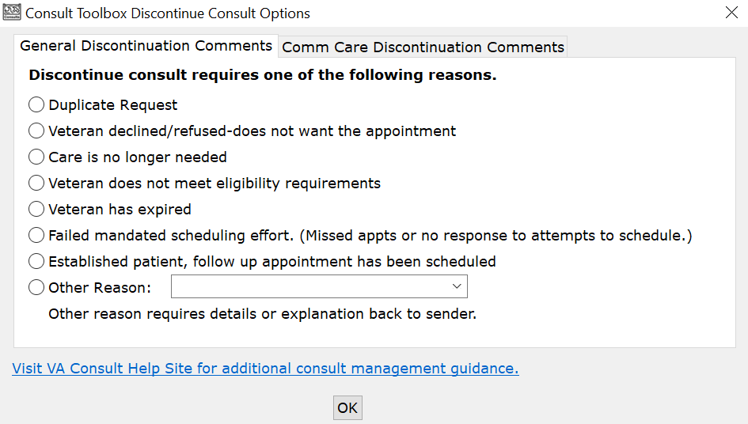

* Discontinue consult requires one of the following reasons section
* **Duplicate Request**
* **Veteran declined/refused-does not want the appointment**
* **Care is no longer needed**
* **Veteran does not meet eligibility requirements** – This is to be used where VA benefits or the Veteran’s clinical situation do not allow them to receive this service from the VA. An example would be routine dental care for a Veteran not eligible for dental care.
* **Veteran has expired** – Use if Veteran is deceased.
* **Failed mandated scheduling effort (Missed appointments or no response to attempts to schedule.)**—use when Veteran has missed two or more appointments, or fails to respond to mandated minimum number of calls, letter(s), and adequate time to respond.
* **Established patient, follow up appointment has been scheduled**—this indicates that the established Veteran has been scheduled with a follow up appointment, and the consult is no longer needed.
* **Other Reason: -** Other reason requires details or explanation back to sender. Several options are available in the dropdown box, or you may type another reason. In addition, selection of this option will prompt for an explanation. This option is used primarily when there is some defect in the request, so feedback to the ordering clinician is appropriate.

Figure : Other Reason Menu Options

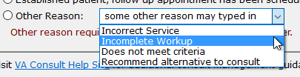

* **Incorrect Service**
* **Incomplete Workup**
* **Does not meet criteria**
* **Recommend alternative to consult**

Figure : Community Care Discontinuation Comments Tab

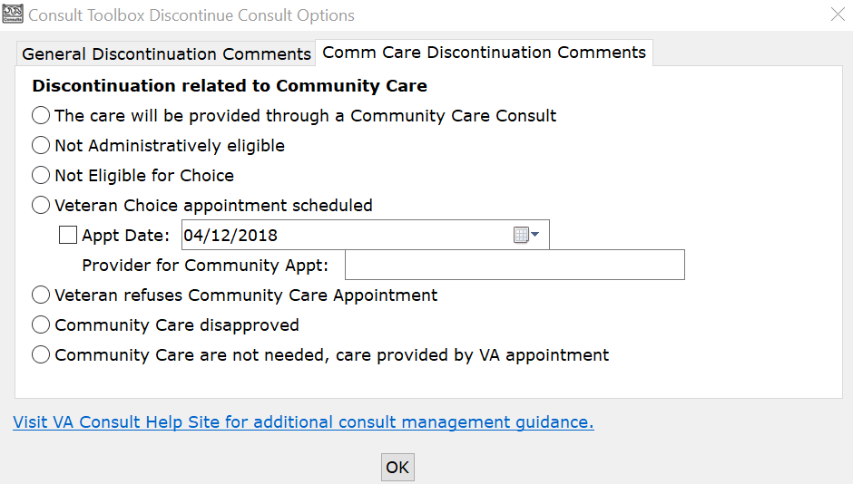

* **Discontinuation related to Community Care** section
* **The care will be provided through a Community Care Consult** – Care will be provided by Non-VA Care. USE WITH CAUTION. This is saying that this consult is being discontinued and a Non-VA Care consult will be issued for this service. Typically, a consult should only be discontinued when a non-VA care appointment has been scheduled (See next option) .

1. This option would be selected when, for example, an Interfacility Consult is sent from Site A to Site B, enabling Choice. The consult would then be discontinued by staff at Site B with instructions to order a Community Care consult at site A.

* **Not Administratively eligible** – Veteran is not eligible.
* **Not Eligible for Choice** – Veteran is not eligible for Choice
* **Veteran Choice appointment scheduled** – This is used when the TPA has confirmed that an appointment has been scheduled for the Veteran.
* **Appt Date:** - Additionally, the date of the appointment can be recorded. Note that the calendar widget contains a default date, so you must check the box to indicate that the date in the box is the appointment date for it to be recorded.
* **Provider for Community Appt:** - If the name of the provider is known, that should be added as well. If the provider name field is filled in, that is also added to the consult comment.
* **Veteran refuses Non-VA Care Appointment** – used when the Veteran refuses non-VA appointment.
* **Community Care disapproved** – used when the request for non-VA care is disapproved or does not meet requirements.
* **Community Care not needed, care provided by another VA appointment** – use when, apart from this consult, the Veteran’s needs were met by care already received at another appointment. Consider using a duplicate request if more appropriate.

### Forward

Figure : Forward to Community Care Options Tab

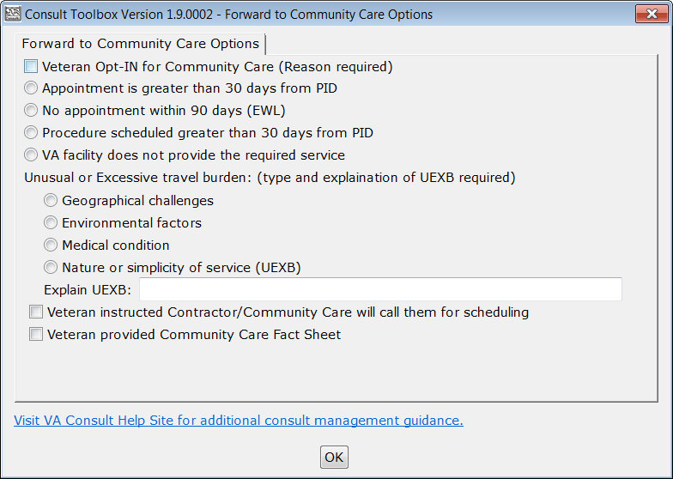

**Forward to Community Care Options** section

* **Veteran Opt-IN for Choice (Reason required)**
* **Appointment is greater than 30 days from PID**
* **No Appointment within 90 days (EWL)**
* **Procedure scheduled greater than 30 days from PID**
* **VA facility does not provide the required service**
* **Unusual or Excessive travel burden (type an explanation of UEXB required)**
* **Geographical challenges (aa)**
* **Environmental factors (bb)**
* **Medical condition (cc)**
* **Nature or simplicity of service (UEXB) (dd)**
* **Veteran instructed Contractor/Community Care will call them for scheduling**
* **Veteran provided Choice Fact Sheet**

### Add Comment: Scheduler Functions

Figure : Calls and Letters Tab

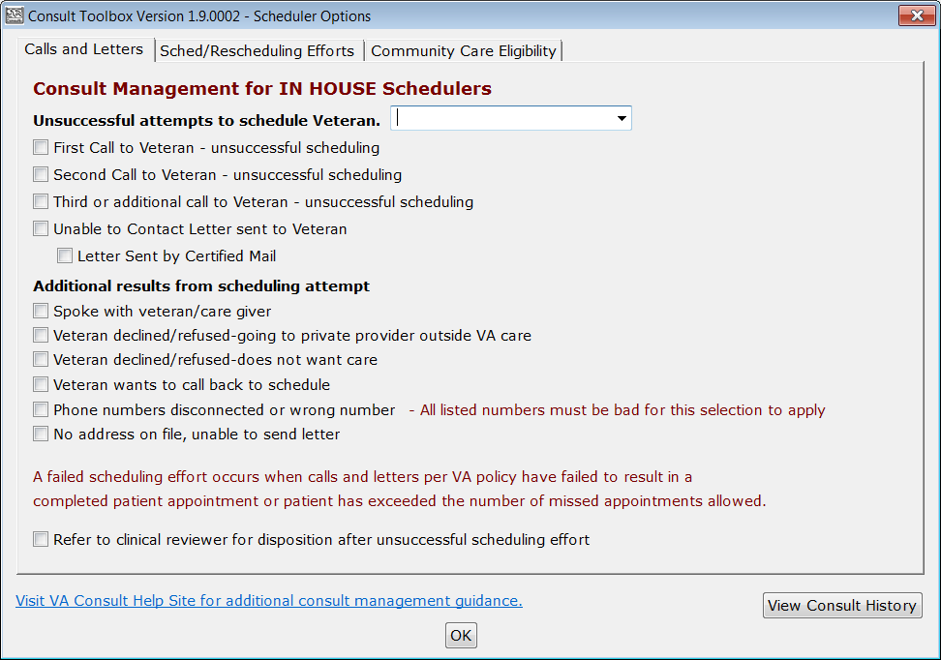

* **Unsuccessful attempts to schedule Veteran** drop-down menu, select the best option.
* **No Answer**—used when you attempt to call the Veteran but there is no voice mail to leave a message.
* **Left message on voicemail**—used when you leave a message on the Veteran’s voice mail to call back. You should not provide any details that might violate PHI restrictions, but your number to return the call would be appropriate.
* **Left message with family member**—used when you speak to a family member, but they are unable to commit to an appointment on behalf of the Veteran.
* **Unable to leave message**—used when you speak to a family member, but they are not able to take a message. You should not provide any details that might violate PHI restrictions, but your number to return the call would be appropriate.
* **Unsuccessful attempts to schedule Veteran**
* Select first, second, or third call to Veteran as appropriate. If the Veteran has no-showed or cancelled, then you need to start over with a new scheduling effort and first, second, and possibly third or additional calls. If you make more than three calls, use the 3rd call for all subsequent calls.
* **Unable to Contact letter sent to Veteran**—use this selection when a letter is sent to the Veteran indicating that the clinic has been trying to reach the Veteran to schedule an appointment. This comment may be used each time a letter is sent, if sent more than once.
* **Letter Sent by Certified Mail**—in the case of high risk consults, business rules for the clinic or upon suggestion of the provider, it may be appropriate to send the Veteran a certified letter indicating that they have a potentially serious condition, and that the VA has been unsuccessful reaching them to provide care.
* **Additional results from scheduling attempt**
* **Spoke with veteran/care giver**—this documents that you did in fact talk to the Veteran or their care giver.
* **Veteran declined/refused – going to private provider outside VA Care** – the Veteran has indicated that they would rather use their private insurance and arrange care outside the VA at his/her own expense.
* **Veteran declined/refused – does not want care** – this selection is used if the Veteran tells the scheduler they do not want to schedule the appointment. Depending on the business rules for the clinic, they may very well require review by a licensed practitioner before discontinuation.
* **Veteran wants to call back to schedule**—this is when you do speak to the Veteran/care giver, but they don’t want to make the appointment at that time, but indicate they’ll call back to schedule. This is an example of a case where the Veteran was reached, but this would count as an unsuccessful attempt to schedule.
* **Phone numbers disconnected or wrong number**—used when all the numbers listed for the Veteran are wrong (disconnected or you reach someone who doesn’t know the Veteran). This should not be used unless you’ve confirmed that all numbers in the record are bad.
* **No address on file, unable to send letter**—this would apply in the instance where a letter sent is returned by the post office, or in the case of homeless Veterans. The latter case may require extra effort with the Homeless Veterans Program to try to reach the Veteran.

Figure : Sched/Rescheduling Efforts Tab

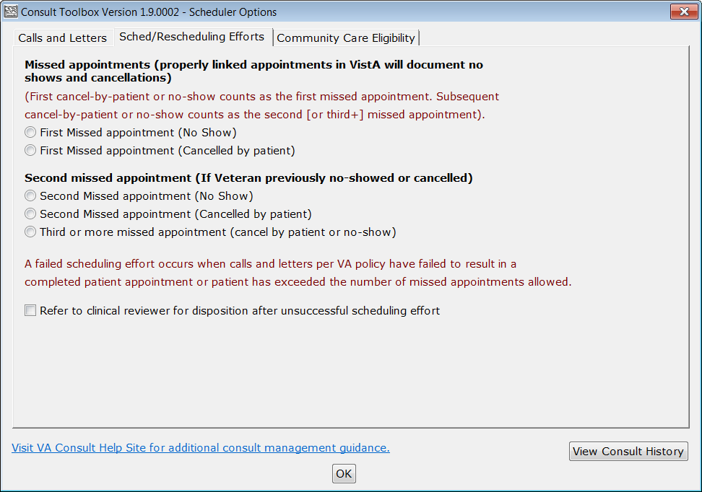

* **Missed appointments**
* **First Missed appointment (No Show)** — missed appointment. It is important to track the missed appointment, as a Veteran who fails to keep appointments may be depriving other Veterans an opportunity to receive care.
* **First Missed appointment (Cancelled by patient)**—this is cancelled-by-Veteran. It is important to track this missed appointment, as a Veteran who fails to keep appointments may be depriving other Veterans an opportunity to receive care.
* **Second missed appointment**
* **Second Missed appointment (No Show)**—missed appointment. This should be recorded, and in addition, if the appointment has been pre-reviewed for discontinuation after two missed appointments, the consult should be discontinued in an additional step. If not pre-reviewed, then it should be referred to the provider for disposition.
* **Second Missed appointment (Cancelled by patient)**—missed appointment. This should be recorded, and in addition, if the appointment has been pre-reviewed for discontinuation after two missed appointments, the consult should be discontinued in an additional step. If not pre-reviewed, then it should be referred to the provider for disposition.
* **Third or more missed appointment (cancel by patient or no-show)**—appointments that are missed either by cancel by Veteran or no-show are tracked here, without distinction.

Figure : Community Care Eligibility Tab

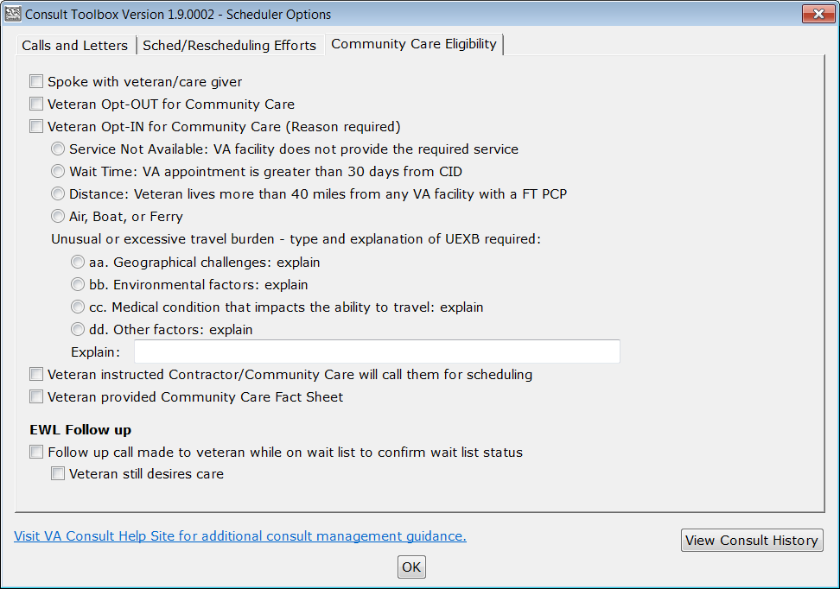

* **Spoke with veteran/ or care giver**—this documents that you did in fact talk to the Veteran or their care giver. Business rules do require speaking to the Veteran before placing them on the EWL or VCL.
* **Veteran Opt-OUT for Choice**—this documents that the Veteran opts out for Choice.
* **Veteran Opt-IN for Choice (Reason required)**—this documents that the Veteran opts in for Choice and the applicable reason(s).
* **Service Not Available: VA facility does not provide the required service**
* **Wait Time: VA appointment is greater than 30 days CID**
* **Distance: Veteran lives more than 40 miles from any VA facility with a FT PCP**
* **Air, Boat, or Ferry**
* **Unusual or Excessive travel burden (type and explanation of UEXB required)**:
* **Geographical challenges: explain**
* **Environmental factors: explain**
* **Medical condition that impacts the ability to travel: explain**
* **Other factors: explain**
* **Veteran instructed Contractor/Community Care will call them for scheduling** –
* **Veteran provided Community Care Fact Sheet**
* **EWL Follow up** section
* **Follow up call made to veteran while on wait list to confirm wait list status.**
* **Veteran still desires care.**

### Add Comment: Community Care Functions

Figure : Community Care Functions Window: MSA Elig. Verification Tab

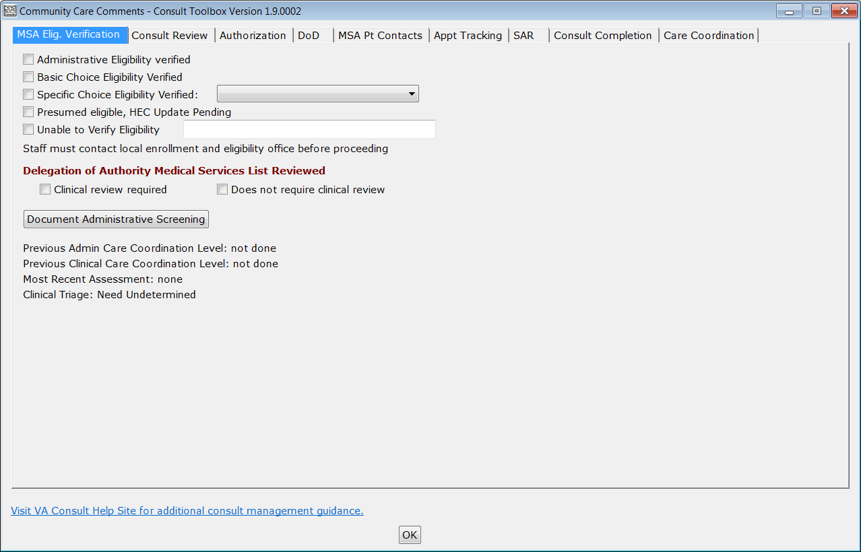

* **Administrative Eligibility verified**—allows Community Care staff to record when administrative eligibility has been verified.
* **Basic Choice Eligibility Verified**—allows Community Care staff to record when a Veteran’s Choice Program eligibility has been verified and that the Veteran is present in VC Viewer.
* **Specific Choice Eligibility Verified**—allows staff to further signify that the Veteran is eligible under one of the administrative eligibilities. This option allows the user to identify Choice eligibility. The drop-down offers the following options:

Figure : Specific Choice Eligibility Verified Menu Options

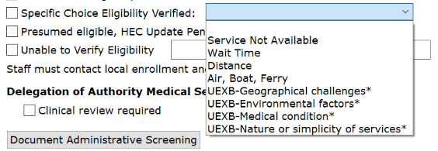

* **Service Not Available**
* **Wait Time –** VA appointment is greater than 30 days Clinically Indicated Date (CID).
* **Distance –** Veteran lives more than 40 miles from any VA facility with a FT Primary Care Physician (PCP).
* **Air, Boat, Ferry**
* **UEXB — Geographical challenges\***
* **UEXB — Environmental Factors\***
* **UEXB — Medical condition\***
* **UEXB – Nature or simplicity of services\***
* **Presumed eligible, HEC Update Pending** —This is typically appropriate when a new Veteran is being registered and all evidence indicates (e.g. a DD 214 form) that the person is indeed a Veteran, but the eligibility cannot be verified by the Health Eligibility Center’s (HEC) systems. This is an indication that the record requires action by the HEC before the consult can move forward.
* **Unable to Verify Eligibility** —Staff member should take steps to verify eligibility. Staff is unable to verify the person’s eligibility for VA care or Community Care. This allows documentation of that fact, and alerts the staff to refer the case to the appropriate person for resolution. A comment is available for further clarification, but is not mandatory.
* **Delegation of Authority Medical Services List Reviewed** section. — This allows staff to select if clinical review is required, by checking a box.
* **Clinical review required**
* **Does not require clinical review**
* **Document Administrative Screening**

Figure : Administrative Screening

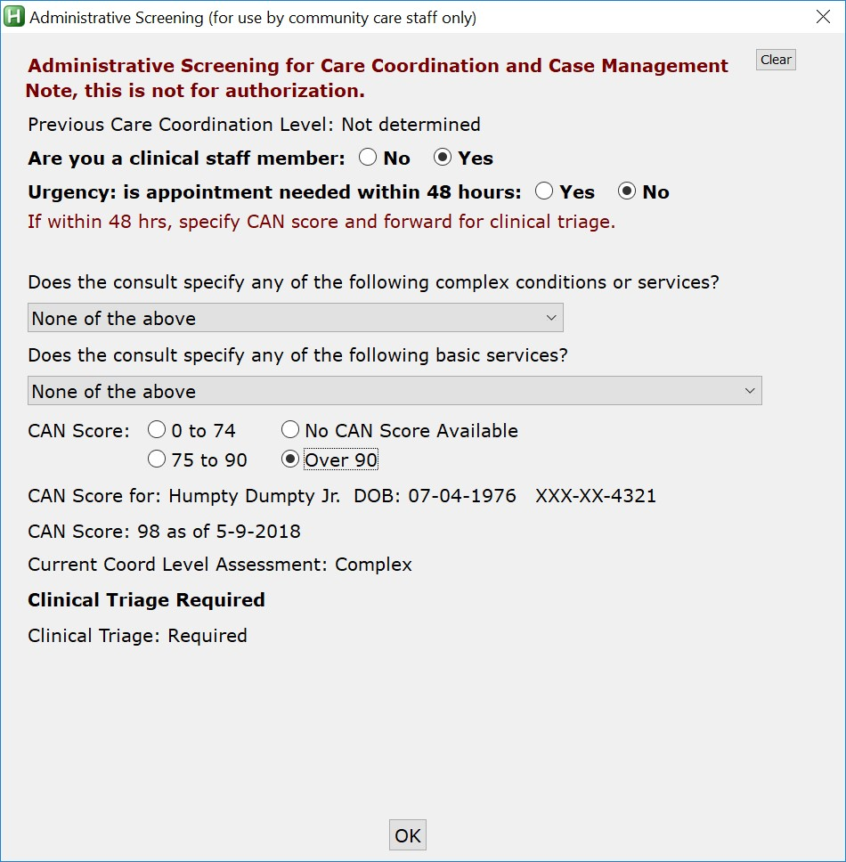

**Administrative Screening for Care Coordination and Case Management** section

* **Are you a clinical staff member:** **Yes** or **No**—the first question asks if you are a clinical staff member. This box will screen to see if clinical staff needs to review an alert, which wouldn’t be needed if the user is a clinical staff person.
* **Urgency:** - is appointment needed within 48 hours—if urgent care coordination is required, this should be forwarded immediately for clinical triage. (If within 48 hours, skip remaining questions and forward for clinical triage.)
* **Does the consult specify any of the following complex conditions or services?** — if the consult specifies any complex conditions or services, select one of the following options from the drop-down menu.
* **New Cancer Diagnosis**
* **Outpatient Surgery**
* **Coronary Artery Bypass (CABG)**
* **Chronic Heart Failure**
* **Chronic Obstructive Pulmonary Disease/Pneumonia**
* **Inpatient Hospitalization (any cause)**
* **None of the above**
* **Does the consult specify any of the following basic services** — if the consult specifies basic services, select the applicable service from the drop-down menu.
* **Routine Follow-up Therapeutics (Pre-scheduled services Dialysis, OT, PT, RT)**
* **Routine Mammography**
* **Cervical Ca Screening (PAP Test)**
* **Direct Scheduling**
* **Routine Screening Colonoscopy**
* **None of the above**
* **CAN Score** — CAN scores serve as an important component to the Screening/Triage process providing a standardized evidence-based measure of Veteran risk. CAN scores measure the probability of inpatient admission or death within a specified time period (1 year) in percentage form. To access a Veteran’s CAN score, the staff will be required to access VSSC. If CAN (Care Assessment Needs) Score is known, make the appropriate selection, or if not available, select **No CAN Score Available** from the following choices:
* **0 to 74**
* **75 to 90**
* **Over 90**
* **No CAN Score Available**
* **Current Coord Level Assessment**: - If this is not **Basic**, a box will open to input the name of the clinical staff member responsible for completing the clinical triage portion of the tool. This is not shown for clinical staff.

1. This does not send the actual alert, the user is responsible for sending the alert using the **Send additional alerts** button on the comment screen:

* **Clinical Triage:** - If the level of care coordination determined in the administrative screening section is not basic, the administrative staff member will alert a clinical care coordinator to complete the clinical triage section below. The clinical section consists of questions regarding the Veteran’s comorbidities, social factors, and need for assistance with Activities of Daily Living (ADLs). There is also a drop-down menu which the clinical care coordinator may fill out to override the results of the tool using clinical evidence-based judgment.

1. If clinical triage has already been performed, it will show. Also, if care coordination has already been assigned by Administrative screening (as in the example below) that will also show.

Figure : Clinical Care Coordination Assignment

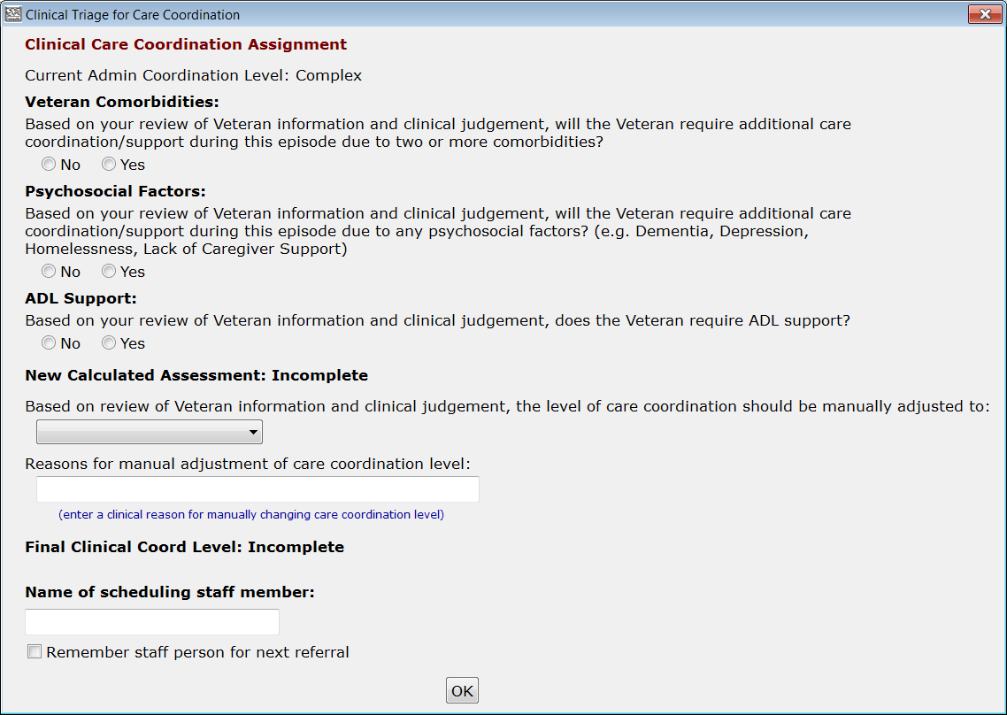

**Clinical Care Coordination Assignment**

The Screening/Triage tool will recommend a care coordination level once the following items are populated:

* **Veteran Comorbidities**—select yes or no if based on your review of Veteran information and clinical judgement if the Veteran will require additional care coordination/support during this episode of care due to two or more comorbidities.
* **Psychosocial Factors**—select yes or no if based on your review of the Veteran information and clinical judgement, if the Veteran will require additional care coordination/support during this episode of care due to any psychosocial factors (e.g. Dementia, Depression, Homelessness, Lack of Caregiver Support).
* **ADL Support**–select yes or no if based on your review of Veteran information and clinical judgement, if the Veteran will require ADL support.
* **New Calculated Assessment** — the tool will calculate a level of care coordination based on the answers in the administrative screening and clinical triage sections as displayed below:
* **Based on review of Veteran information and clinical judgement, the level of care coordination should be manually adjusted to**: - Based on clinical judgment, the clinical care coordinator may override the automated result. If manual adjustment is required for the level of care coordination, select the revised level in the drop-down menu along with the reason for adjustment in the textbox below.
* **Basic**
* **Moderate**
* **Complex**
* **Urgent**
* **Reasons for manual adjustment of care coordination level** — enter a clinical reason for manually changing care coordination level.
* **Final Clinical Triage Coordination Level**: - auto-populates based on the completion of clinical triage questions or manual override.
* **Name of scheduling staff member**: - Name of the scheduling staff member.
* **Remember staff person for next referral** – option that tells the Consult Toolbox to remember the selected staff person for the next referral.

Figure : Consult Review Tab

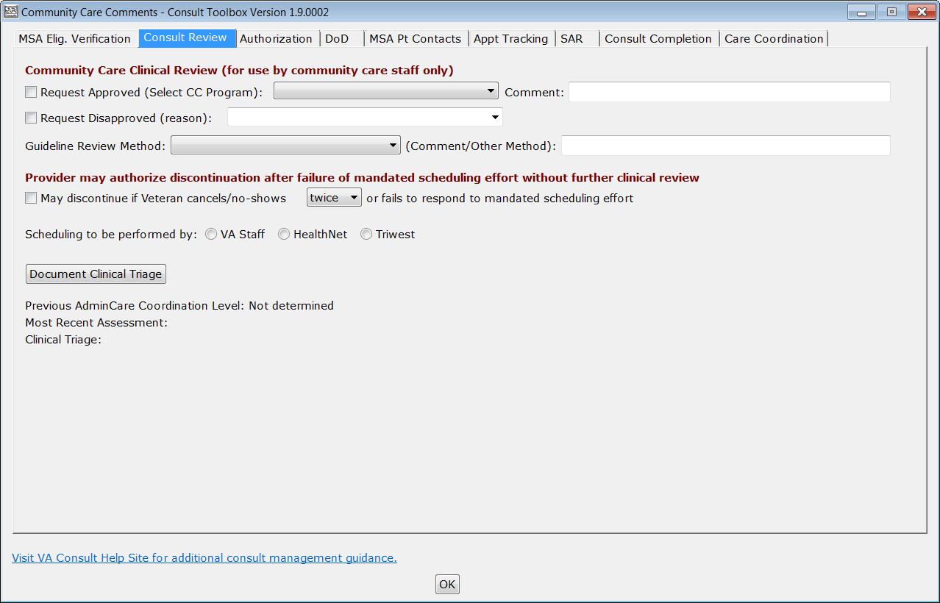

* **Community Care Clinical Review** **(for use by community care staff only)**
* **Request Approved (Select CC Program)**—various Community Care programs can be selected but must be one of the listed in the drop-down menu.

Figure : Request Approved (Select CC Program) Menu Options

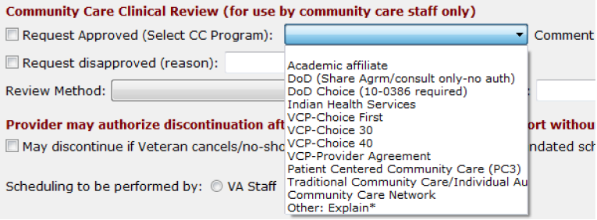

* **Academic Affiliate**
* **DoD (Share) DoD Share Agreement, Consult Only-No Auth**
* **DoD (Choice) DoD Choice, 10-0386 Authorization Required**
* **Indian Health Services**
* **VCP-Choice First**
* **VCP-Choice 30**
* **VCP-Choice 40**
* **VCP-Provider Agreement**
* **Patient Centered Community Care (PC3)**
* **Traditional Community Care/Individual Authorization**
* **Community Care Network**
* **Other: Explain\***

1. If you are located in Alaska , Tribal will be an additional option in the **Request Approved (Select CC Program)** drop-down menu.

* **Comment:**
* **Request disapproved (reason)** —reason request disapproved, select option or type other reason.
* **Guideline Review Method**: various methods can be selected from the list, and an additional comment field is available.

Figure : Guideline Review Method Menu Options

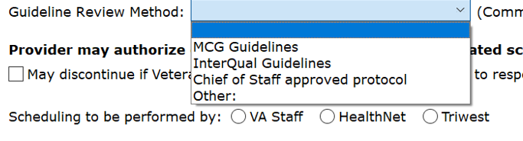

* **MCG Guidelines**
* **InterQual Guidelines**
* **Chief of Staff approved protocol**
* **Other:**
* **(Comment/Other Method)**
* **May discontinue if Veteran cancels/no-shows or fails to respond to mandated scheduling effort** — If the Provider authorizes discontinuation after failure of mandated scheduling effort without further clinical review
* **Scheduling to be performed by**
* **VA Staff —** Scheduling to be performed by.
* **TriWest —** Scheduling to be performed by.

Figure : Authorization Tab

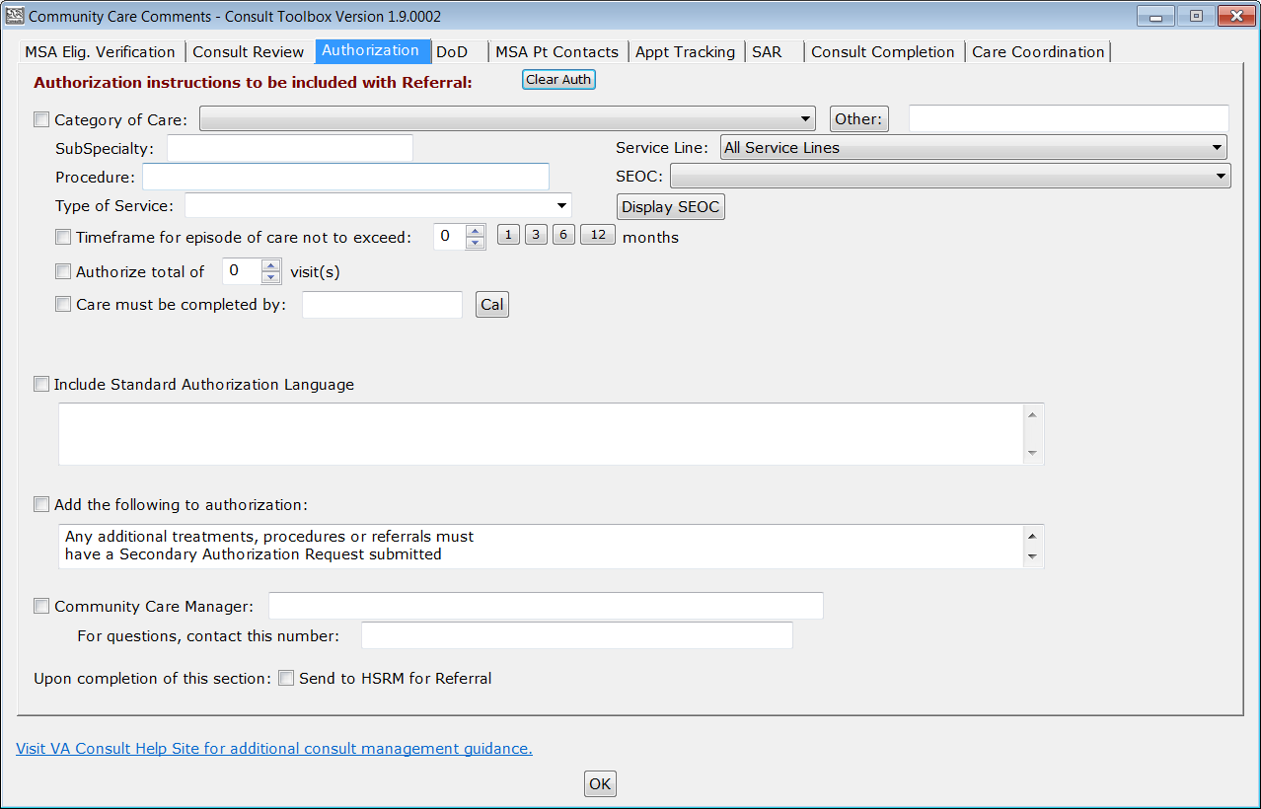

* **Category of Care** — will populate from the underlying consult if it has been previously specified in the consults. If it has been specified more than once, the most recent will populate. At first the Check Box will not be selected. If selected, it will insert the Category of Care into the consult. If there’s no change in the authorization, there’s no reason to insert it again. This list is populated with approved categories of care, so these should preferentially be used if possible. If none of these categories of care can be used, select the **Other button** and free text the new Category of Care in that field.

1. In most cases the preference is to use one of the identified specialties, and if further clarification is needed, please use the subspecialty field.

* **Subspecialty** — is an optional field, which can be used if necessary for a highly specialized service needed by the Veteran.
* **Service Line –** Group of Standardized Episode(s) of Care (SEOCs).
* **Procedure** — is typically going to be an office visit and/or some surgical procedure, diagnostic procedure or other type of service.
* **SEOC** — is an optional field, which can be used if necessary to select a SEOC for the Veteran from the active SEOCs in the SEOC database. To select a SEOC, the request must be approved on the **CC Consult Review** tab.

Figure : SEOC Menu Options

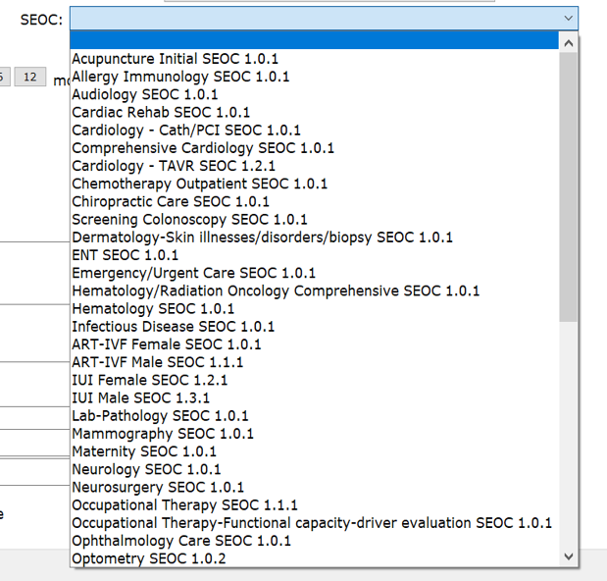

* **Type of Service** – drop-down field with four options: **Evaluation and Treatment**, **Evaluation and Recommendations**, **Treatment**, and **Diagnostic**.
* **Timeframe for episode of care not to exceed** — number of months past first appointment—for service is 3 months from the date of the first visit, but may be modified up to 12 months.
* **Authorize total of number of visits** — defaults to 1, and includes the initial consultation.
* **Care must be completed by** — this is to provide a cut-off date for care, which may become important as the “Choice” program expires and new Community Care legislation may be passed by Congress.
* **Include standard Authorization Language** — this will insert whatever language appears in the box. The contents of this box will persist from one consult to the next, so this is typically used for any standardized verbiage used for ALL consults.
* **Add the following to authorization** — this will allow for additional pertinent information. Note: any additional treatments, procedures or referrals must have a Secondary Authorization Request submitted.
* **Community Care Manager** — typically referrals need to include the name of the Community Care manager, and a contact number. These can be inserted here. You must check the checkbox for this to be included.
* **Upon completion of this section** — send to HSRM for referral.

Figure : DoD Tab

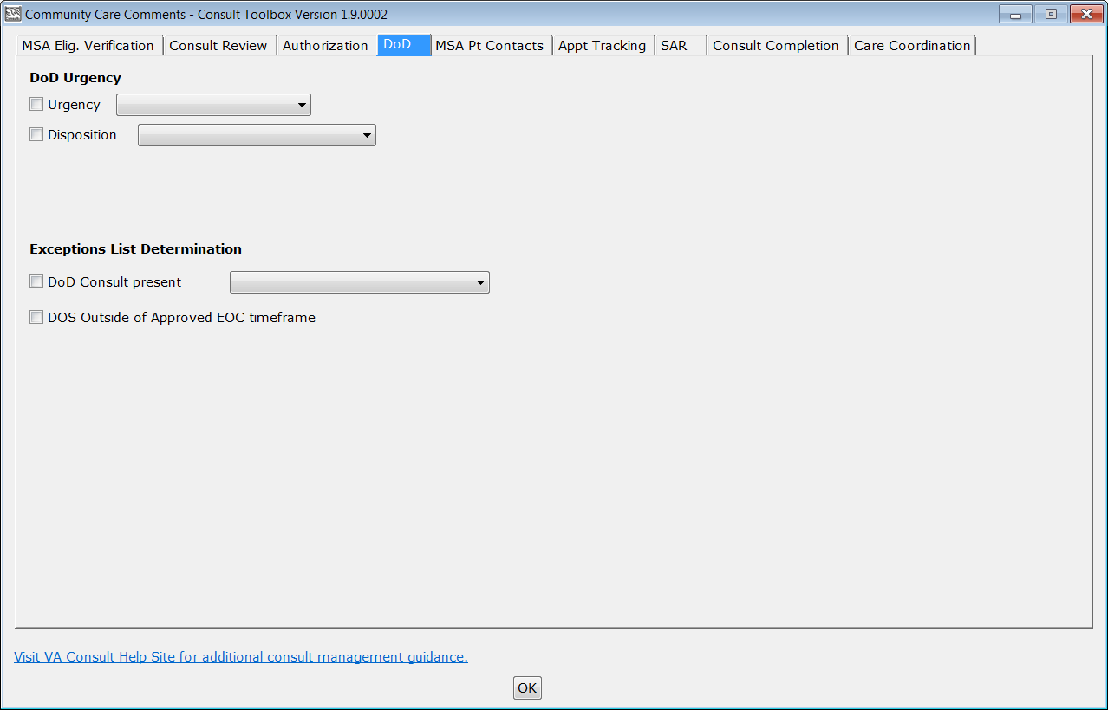

* **DoD Urgency**
* **Urgency** –

Figure : DoD Urgency Menu Options

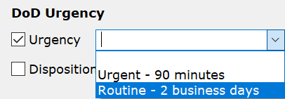

* **Urgent – 90 minutes**
* **Routine – 2 business days**
* **Disposition** –

Figure : Disposition Menu Options

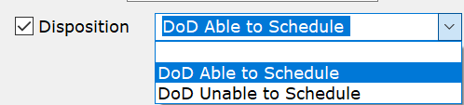

* **DoD Able to Schedule**
* **DoD Unable to Schedule**

1. If **DoD Unable to Schedule** is selected, then the **Unable to Schedule (reason):** check box and drop-down menu will display.

Figure : Unable to Schedule (reason): Menu Options

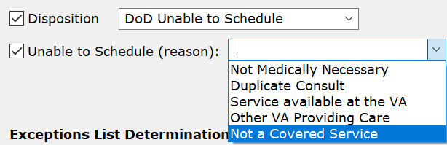

* **Not Medically Necessary**
* **Duplicate Consult**
* **Service available at the VA**
* **Other VA Providing Care**
* **Not a Covered Service**
* **Exceptions List Determination**
* **DoD Consult present** –

Figure : DoD Consult Present Menu Options

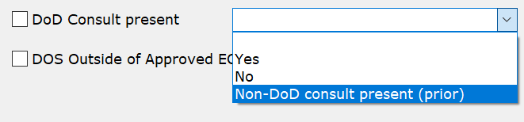

* **Yes**
* **No**
* **Non-DoD consult present (prior)**
* **DOS Outside of Approved EOC timeframe** –

1. If **DOS Outside of Approved EOC timeframe** is selected, then the **Exception Disposition** check box and drop-down menu will display.

Figure : Exception Disposition

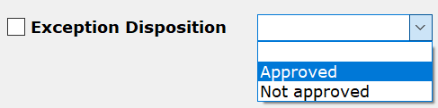

* **Approved**
* **Not approved**

Figure : MSA Pt Contacts

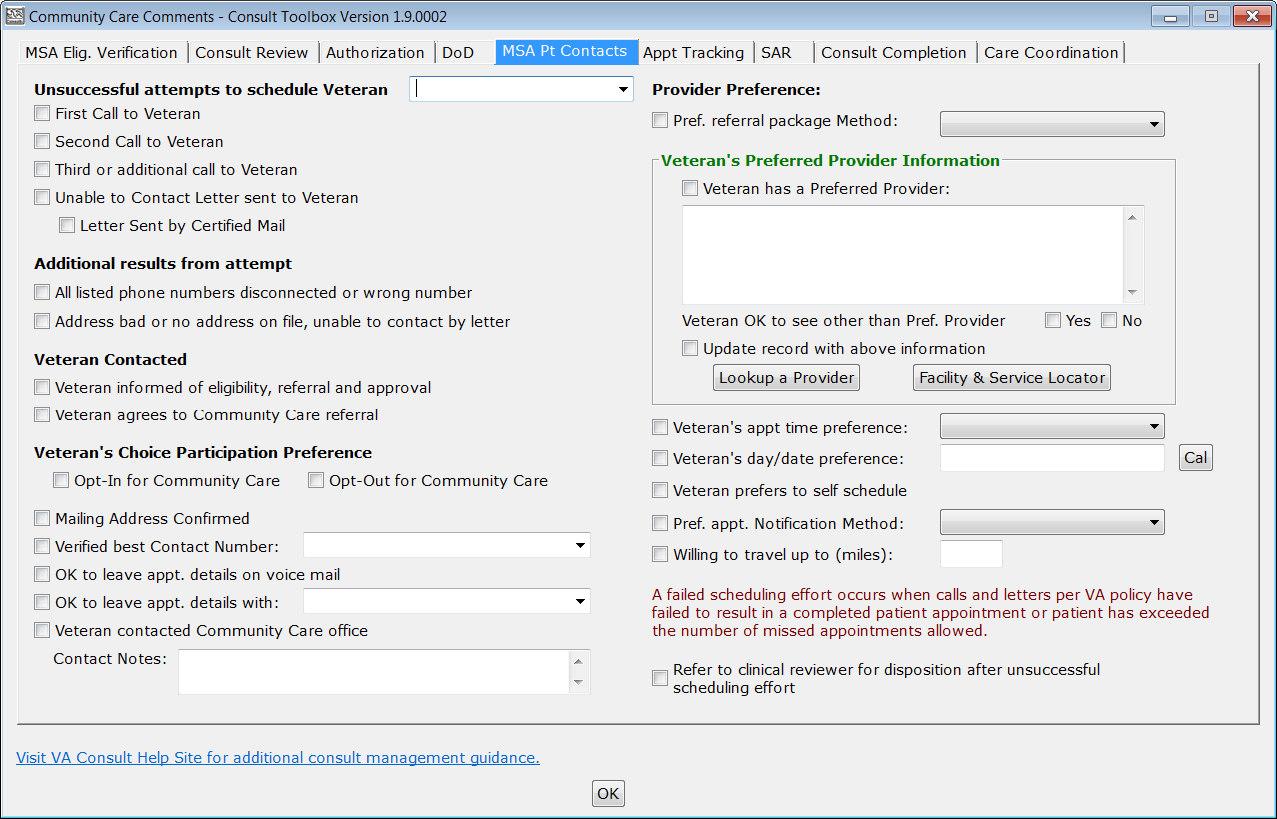

* **Unsuccessful attempts to schedule Veteran** — this allows recording first, second, and additional calls made to the Veteran to arrange care. Optionally, an annotation like “No Answer” can be added. Select from those available, or add any free text. Selections are:
* **First call to Veteran**
* **Second call to Veteran**
* **Third or additional call to Veteran**
* **Unable to Contact letter sent to Veteran** — use this selection when a letter is sent to the Veteran indicating that the clinic has been trying to reach him/her to schedule an appointment. This comment may be used each time a letter is sent, if sent more than once.
* **Letter Sent by Certified Mail**—this is an additional indication that the letter above was sent by certified mail. Note that the certified mail indicator should be used in conjunction with the unable to contact letter.
* **Additional Results from Attempt**
* **All listed phone numbers disconnected or wrong number**—used when all the numbers listed for the Veteran are wrong (disconnected or you reach someone who doesn’t know the Veteran). This should not be used unless you have confirmed that all numbers in the record are bad.
* **Address bad or No address on file, unable to contact by letter**—this would apply in the instance where a letter sent has been returned by the post office or in the case of homeless Veterans. The latter case may require extra effort with the Homeless Veterans’ Program to try to reach the Veteran.
* **Veteran Contacted**
* **Veteran Informed of eligibility, referral, and approval**—this simply documents that the Veteran has been informed of choice eligibility.
* **Veteran Agrees to Community Care referral**
* **Veteran’s Choice Participation Preference**
* **Opt-In for Choice**—documents Veteran has opted-in.
* **Opt-Out for Choice**—documents Veteran has opted-out for choice.
* **Mailing Address Confirmed**—indicates that the mailing address on file is correct. If not correct, MSA should correct the address, and then confirm that it is correct.
* **Verified Best Contact Number**—documents best number to contact this Veteran. In addition to the actual number, user may also note whether cell, home, or other number. Also, options to confirm existing numbers on file as the best number are provided.

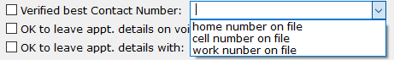

* **OK to leave appt. details on voice mail**—documents that Veteran gives permission to leave appointment details on his/her voice mail.
* **OK to leave appt. details with family**—documents that Veteran gives permission to leave details of the appointment with a family member. Anything may be entered, or several options are provided if a specific family member is preferred.

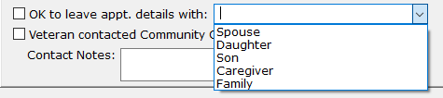

* **Veteran contacted Community Care office**
* **Contact Notes**
* **Pref. referral package Method:**
* **Fax**
* **HSRM Portal**
* **Mail**
* **Secure Email**
* **Virtru Pro**
* **Veteran’s Preferred Provider Information** — if the Veteran has a provider they would like to see, that can be recorded here. Use the lookup tool so the correct provider information (including NPI number) can be part of the record. This pulls data from the Department of Health and Human Services database, which is updated daily
* **Veteran has a Preferred Provider**: Finding the preferred provider can be conducted using the **Lookup a Provider** option.

Figure : Search by Provider Tab

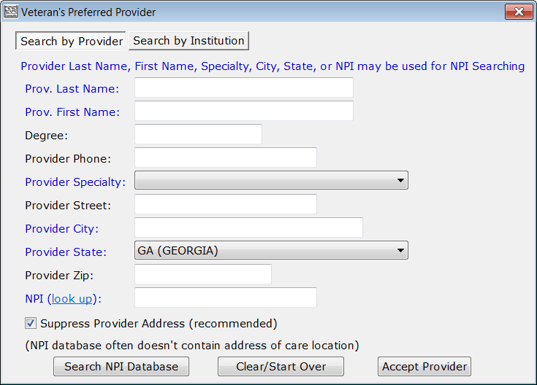

* **Prov. Last Name:** - This field may be used for NPI searching.
* **Prov. First Name:** - This field may be used for NPI searching.
* **Degree:**
* **Provider Phone:**
* **Provider Specialty:** - This field may be used for NPI searching.
* **Provider Street:**
* **Provider City:** - This field may be used for NPI searching.
* **Provider State:** - This field may be used for NPI searching.
* **Provider Zip:**
* **NPI (look up):** - This field may be used for NPI searching.
* **Suppress Provider Address (recommended)**

Figure : Search by Institution Tab

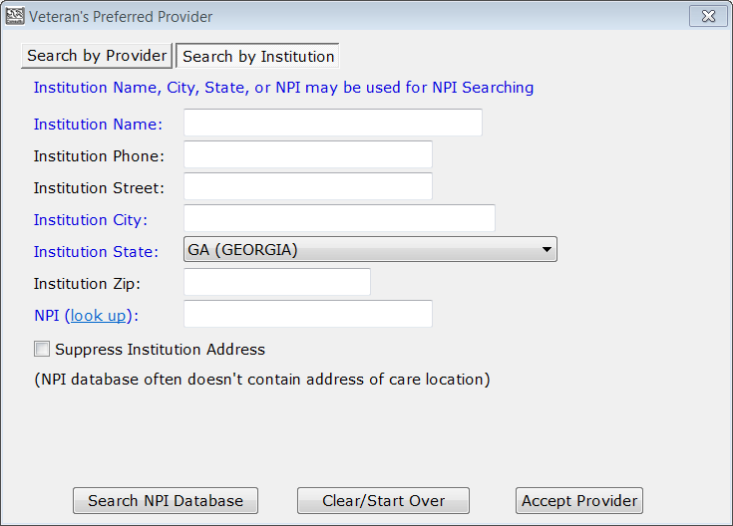

* **Institution Name:** - This field may be used for NPI searching.
* **Institution Phone:**
* **Institution Street:**
* **Institution City:** - This field may be used for NPI searching.
* **Institution State:** - This field may be used for NPI searching.
* **Institution Zip:**
* **NPI (look up):** - This field may be used for NPI searching.
* **Suppress Institution Address**
* **Veteran OK to see other than Pref. Provider** — if the Veteran has indicated a preferred provider, this documents whether they are willing so see someone else if there is no opportunity to see their preferred provider (provider not available or not willing to take Veteran).
* **Update record with above information**
* **Veteran’s appt time preference:** this is an optional field that allows documentation of time of day preference. It can be “Any,” “Morning,” “Afternoon,” or anything else you’d like to enter.
* **Veteran’s day/date preference:** documents day of week or date Veteran would prefer the appointment. This is a free text field, though a CAL button is available to pick a specific date.
* **Veteran prefers to self schedule**
* **Pref. appt. Notification Method:** documents how the Veteran would like to be notified of appointment when scheduled. Options are
* **Mail**
* **Phone**
* **Both by phone and mail**
* **MHV Secure Message**
* **Willing to travel up to (miles):** documents Veteran’s willingness to travel said number of miles to see a provider.
* **Refer to clinical reviewer for disposition after unsuccessful scheduling effort** — after failing to schedule an appointment by making two calls, sending a letter, and waiting two weeks, this option refers the consult to a clinician to review and disposition. Business rules for certain low-risk consults may allow the scheduler to discontinue without clinician review, or in the case the provider previously reviewed the consult and determined that it may be discontinued after a failure to schedule after mandated effort, or multiple missed appointments.

Figure : Appt Tracking Tab

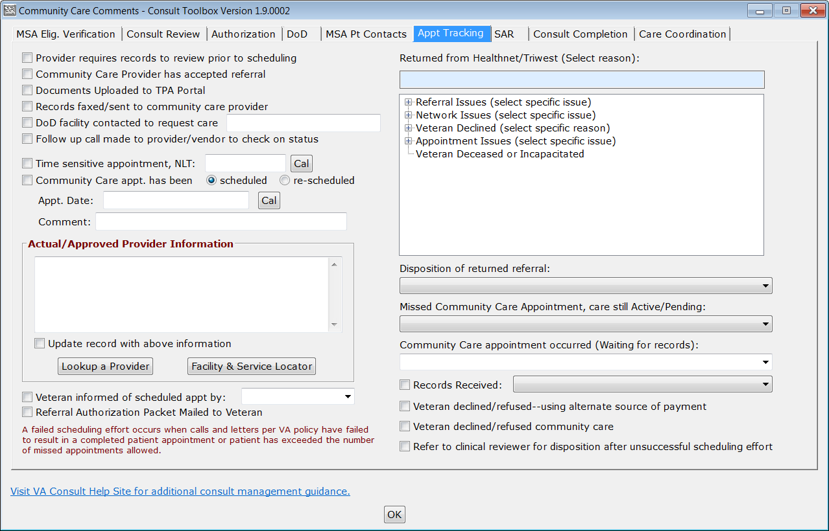

* **Provider requires records to review prior to scheduling** — records a situation where the potential Community Care provider requires records to be reviewed prior to accepting the referral.
* **Community Care Provider has accepted referral** — records when (as in the instance above) a Community Care provider agrees to accept the referral.
* **Document Uploaded to TPA Portal** — allows Community Care staff to record when documentation for a Community Care referral has been uploaded to the TPA’s portal. Note, during the document upload process, the unique ID will also be included.
* **Records faxed/sent to community care provider**—records sent directly to community care provider.
* **Follow up call made to provider/vendor to check on status**—documents a follow up call to vendor to check on referral status, such as in the case where records review was required.
* **Time sensitive appointment, NLT**—documents a no later than date for the appointment to be scheduled.
* **Community Care apt has been—scheduled or unscheduled**. This allows Community Care staff to flag the consult as having an appointment under Community Care.
* **Appointment Date**: Records the appointment date. This is not required if a shadow appointment has been scheduled in VistA Scheduling. This is a free text entry field, however a calendar widget is provided for easy date and time entry.

Figure : Appointment Date Calendar View

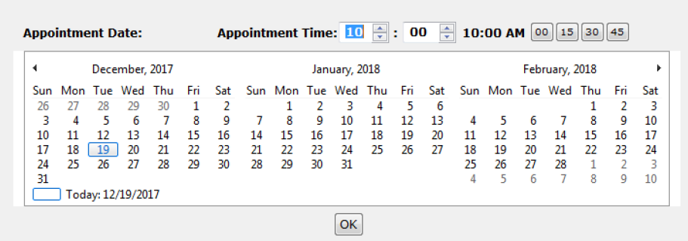

* **Actual/Approved Provider Information** — The name of the actual provider with whom the Veteran has an appointment should be selected using the **Lookup a Provider** button, which works the exact same as the one on the MSA Pt Contacts tab. It may be different from the one the Veteran preferred if, for instance, the provider was unable to see Veteran, or was not participating as a VA community provider.
* **Veteran informed of scheduled appointment**—documents Veteran notification of scheduled appointment through mail, phone, phone and mail, or My HealtheVet.
* **Referral Authorization Packet Mailed to Veteran**—referral authorization packet mailed to Veteran
* **Returned from Health Net/TriWest (Select reason)** — These data fields are used to indicate when a referral has been returned from Health Net or TriWest with the corresponding rationale.
* **Referral Issues (select specific issue)**
* **Missing VA Data** — Missing or incomplete documentation required to appoint.
* **Duplicate**
* **Non Covered Service** — Veteran referred to community provider for services that are not part of benefits package.
* **Missing VA Data/Forms** — Missing or incomplete documentation required to appoint.
* **VA requested return of referral** — VA contacts contractor and requests return of referral.
* **Unable to review within contract standards** — Contractor was not able to review within the contract standard.
* **Non-Disclosure of OHI by Veteran** — Veteran acknowledges having OHI and fails to provide.
* **Unable to contact Veteran during Out Bound Call Process** — Could not appoint due to no contact from Veteran via call or letter.
* **Network Issues (select specific issue)**
* **No Network Provider Available** — No network provider available for requested service(s). This does not include a Veteran requesting a specific provider.
* **VA Requested Providers Outside of Network** — Non‐contracted provider.
* **Veteran Requested Specific Provider** — Veteran requested a specific provider for care that is not available on the PC3 network or by Choice provider agreement.
* **Appointed with Incorrect Provider/Type of Care** — Appointed with incorrect provider or incorrect type of care.
* **Already Appointed** — Care has been previously scheduled by the Veteran, VA or the Contractor.
* **Veteran Declined (select specific reason)**
* **Veteran Declined Distance** **— Inside Commute Standard** — Network provider is in contractors’ network and within the commute standards.
* **Veteran Declined Distance — Outside Commute Standard** — Network provider is in contractors’ network but provider is NOT within the commute standards.
* **Veteran Declined Appt Time** — Veteran declined time for scheduled appointment.
* **Veteran Declined Does Not Want Care** — Veteran declined request for care.
* **Veteran Declined Use of PC3/Choice** — Veteran no longer wants to participate in the program.
* **Declined Use of PC3/Choice** — Veteran no longer wants to participate in the program.
* **Does Not Want Care** — Veteran declined request for care.
* **Appointment Issues (select specific issue)**
* **Veteran No-Show** — Veteran did not show up for scheduled appointment.
* **Contractor Return** — Unable to schedule within contract terms — Care not scheduled within the contractual time and VA is requesting back due to time lapse.
* **VA Request Return** — Care Already Scheduled by Contractor — VA requested the authorization after Contractor scheduled care.
* **Unable to contact Veteran Out Bound Call Process** — Could not appoint due to no contact from Veteran via call or letter.
* **Veteran Deceased or Incapacitated** — Authorization returned due Veteran deceased or incapacitated.
* **Disposition of returned referral**: - document the status of the referral
* **Scheduled using Provider Agreement.**
* **In-house VA Appointment arranged.**
* **Forwarded to in-house service.**
* **Resubmitted new referral authorization to vendor.**
* **Scheduled using traditional Non-VA Care.**
* **Missed Community Care Appointment, care still Active/Pending:** - document the reason for the missed appointment.
* **Veteran was No-Show for community care appointment**
* **Veteran Cancelled community care appointment (Cancel by veteran)**
* **Community Care provider cancelled appointment (Cancel by clinic)**
* **Community Care Appointment occurred (Waiting for records)** — Document that the appointment occurred without receipt of medical records.
* **Per Veteran, awaiting records/confirmation.**
* **Per TPA Portal, awaiting records.**
* **Per Provider, awaiting records.**
* **Records Received**—Document the mechanism that medical records were received.
* **Paper Fax**
* **eFax**
* **Comm. Care Portal**
* **VHIE/VLER**
* **Virtru Pro Secure Email**
* **Other Secure Email**
* **US Mail**
* **EDI Claim Attachment**
* **Other**
* **Veteran Declined/Refused – using alternate source of payment**
* **Veteran Declined/Refused Community Care**
* **Refer to clinical reviewer for disposition after unsuccessful scheduling effort** — after failing to schedule an appointment by making two calls, sending a letter, and waiting two weeks, this option refers the consult to a clinician to review and disposition. Business rules for certain low-risk consults may allow the scheduler to discontinue without clinician review, or in the case the provider previously reviewed the consult and determined that it may be discontinued after a failure to schedule after mandated effort, or multiple missed appointments.

Figure : SAR Tab

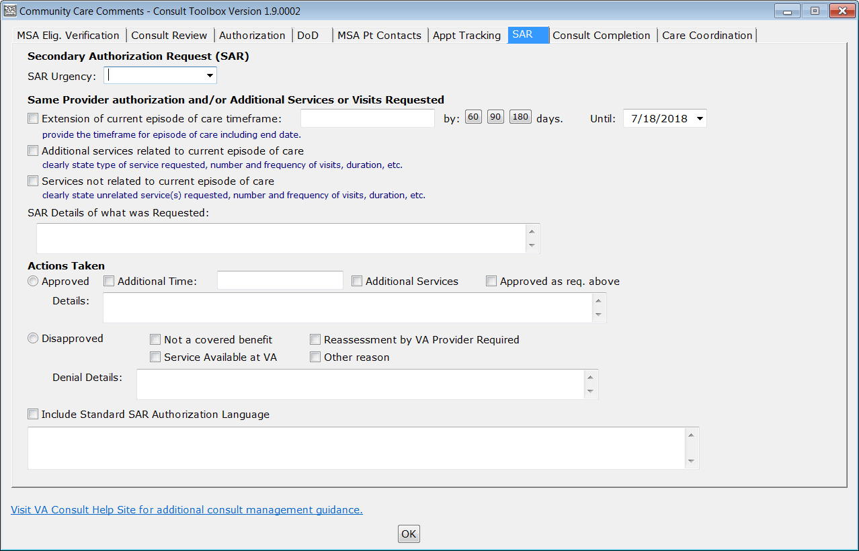

* **Secondary Authorization Request (SAR)** section
* **SAR Urgenc**y — Insert the urgency for the secondary authorization request.
* **Same Provider authorization and/or Additional Services or Visits Requested**
* **Extension of current episode of care timeframe**: - provide the timeframe for episode of care including end date.
* **Additional services related to current episode of care** – clearly state type of service requested, number and frequency of visits, duration, etc.
* **Services not related to current episode of care** – clearly state unrelated service(s) requested, number and frequency of visits, duration, etc.
* **SAR Details of what was Requested: -** comment related to the SAR.
* **Actions Taken**
* **Approved**
* **Additional Time**
* **Additional Services**
* **Approved as req. above**
* **Details**
* **Disapproved** — note reasons by check boxes, or with detailed description.
* **Not a covered benefit**
* **Reassessment by VA Provider Required**
* **Service Available at VA**
* **Other reason**
* **Denial Details:**
* **Include Standard SAR Authorization language**—this is a free text field to insert additional authorization language for the secondary authorization request.

Figure : Consult Completion Tab

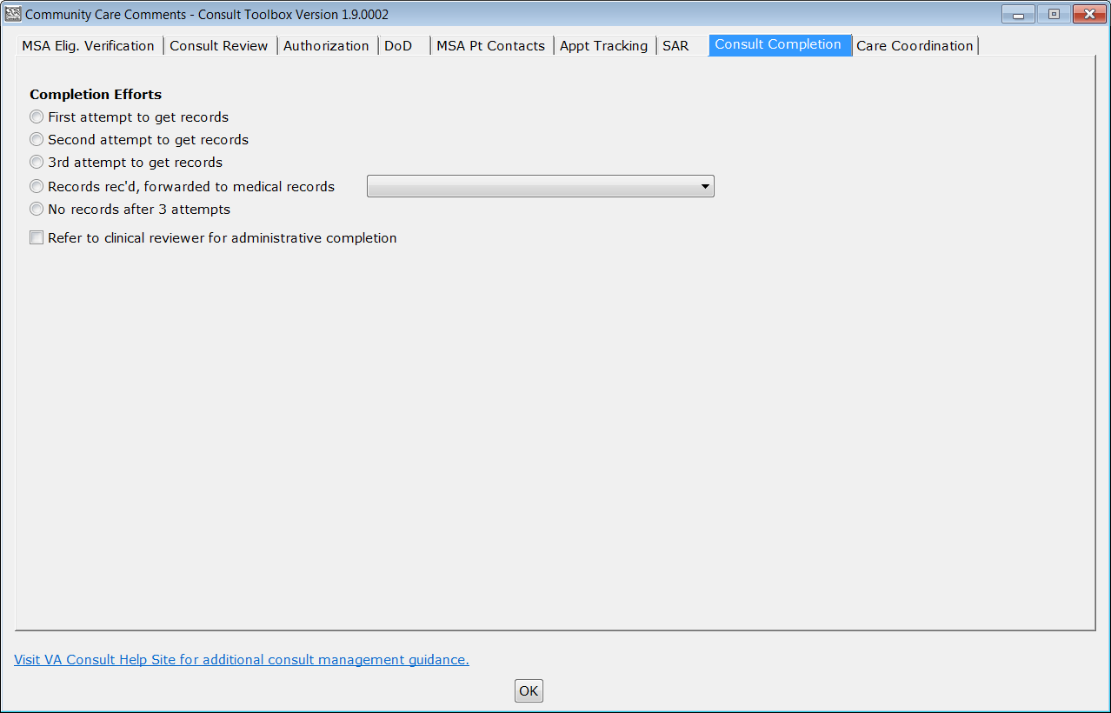

* **Completion efforts**
* **First attempt to get records** — documents first request for records for Community Care (this is a CBO required notation for all three attempts to get records).
* **Second attempt to get records** — documents second request for records for Community Care.
* **3rd attempt to get records** — documents third request for records for Community Care.
* **Records rec’d, forwarded to medical records**. — documents receipt of records pertinent to this consult. This is particularly useful in the case that those records cannot be uploaded to VistA Imaging immediately.

Figure : Records rec’d, forwarded to medical records Menu Options

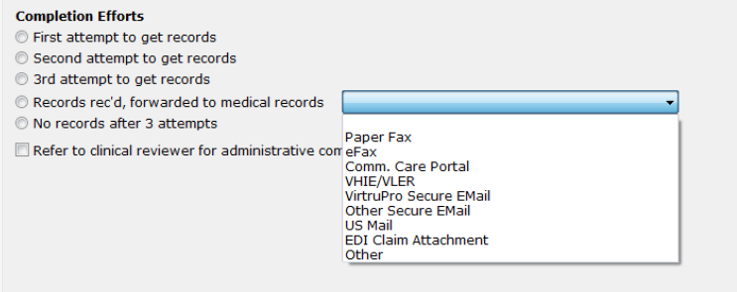

* **Paper Fax**
* **eFax**
* **Comm. Care Portal**
* **VHIE/VLER**
* **Virtru Pro Secure Email**
* **Other Secure Email**
* **US Mail**
* **EDI Claim Attachment**
* **Other**
* **No records after 3 attempts.** — documents that three attempts have been made to receive records. This makes the consult a candidate for administrative closure.
* **Refer to clinical reviewer for administrative completion** — clinical review determines next steps after care when there are no records.

Figure : Care Coordination Tab

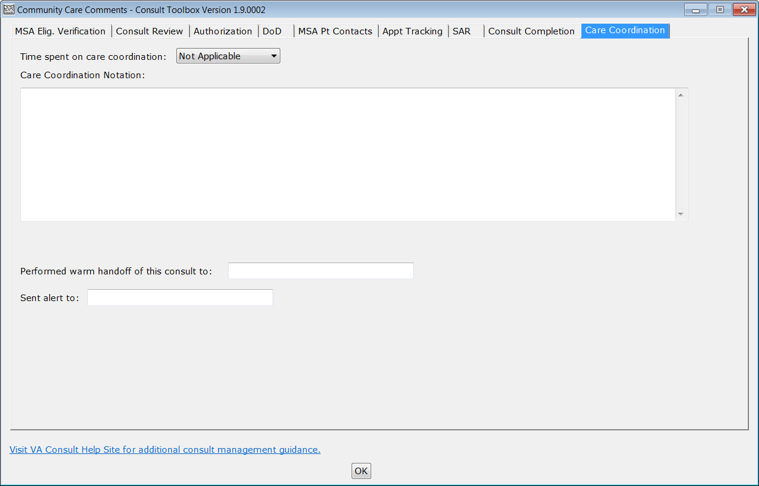

* **Time spent on care coordination** — Insert the time spent on care coordination.
* **Care Coordination Notation** — A free text field to note any care coordination activities.
* **Performed warm handoff of this consult to**: - A warm handoff means that an actual person to person conversation took place between the person making the entry and the recipient of the warm hand off, AND that the recipient has acknowledged receipt of the hand off.
* **Sent alert to**: - Documents that an alert is being sent to another staff member, but there’s been no conversation where the recipient has acknowledged they will follow up. Initials and abbreviations are permissible, if they are standardized for the department. Alert details are not recorded in CPRS, but can be reported using a FileMan report, if needed.

### Add Comment: Clinical Review Options

Figure : Clinical Review Options

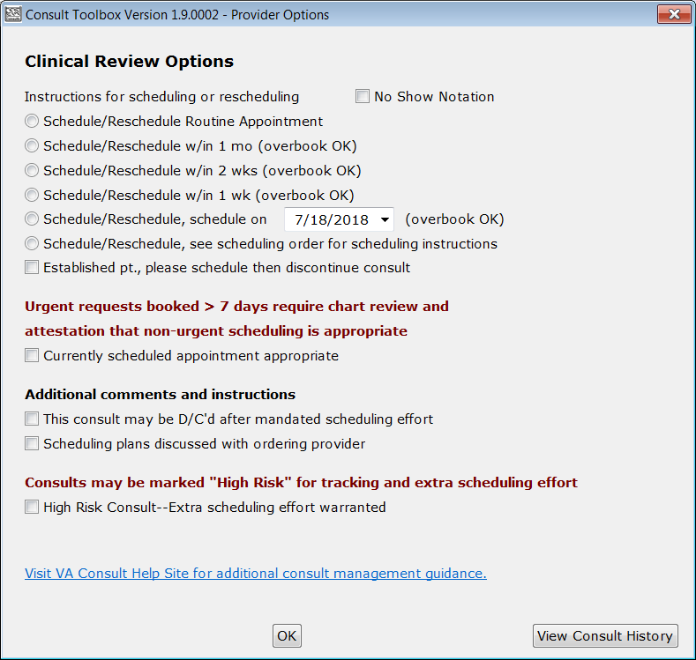

* **Instructions for scheduling or rescheduling** — Providers reviewing consults need to comment when they review incomplete consults (this is different from when they review a consult to accept or receive it). This can occur after a no show, or if a consult has languished, or as the result of failed scheduling efforts. An urgent consult that isn’t seen urgently must be reviewed to assure that either it wasn’t urgent medically, or the delay is the fault of the Veteran. The workflow here is that a routine appointment follows the normal scheduling protocols. If the provider indicates the appointment should be scheduled within a certain time frame, then an overbook may be required. For the scheduler, he or she should first look for an open appointment within the designated time frame, using an available appointment if one is available. Only overbook if no appointment is available. For example, if the provider says within two weeks, and there is an open appointment in 10 days, it would be inappropriate to overbook in six days when there is an open appointment available.
* **No Show Notation** —
* **Schedule/Reschedule Routine Appointment**—this option is available here, but more likely would be used in the “Receive Consult” box described in more detail below.
* **Schedule/Reschedule within 1 month (overbook OK)** —
* **Schedule/Reschedule within 2 weeks (overbook OK)** —
* **Schedule/Reschedule within 1 week (overbook OK)** —
* **Schedule/Reschedule, schedule on date (overbook OK)** —
* **Schedule/Reschedule, see scheduling order for scheduling instructions** —
* **Established pt., please schedule then discontinue consult** — the work flow here is important. It could be that something new has happened with the Veteran and the referring provider felt that an appointment was needed, or it could be that the referring provider didn’t realize the Veteran was already active with the clinic. If there is indeed something new going on with the Veteran, it would not be inappropriate to complete the consult as an e-consult, but in either case, the consult should result in a follow-up appointment. Typically, you’d select scheduling instructions above, and then instruct the scheduler to discontinue the consult once the follow up appointment has been scheduled.
* **Urgent requests booked > 7 days require chart review and attestation that non-urgent scheduling is appropriate.**
* **Currently scheduled appointment clinically appropriate**—this option is for STAT consults that are scheduled more than 7 days from the create date, but after clinical review, are felt to be appropriately timed. This step is extremely important for both STAT consults and those consults stop codes identified as Level 1 (“Important and Acute”) such as cardiology, radiology, oncology, etc. The VA is wanting to make sure that Veterans with high risk conditions receive timely care. Many consults in those high-risk specialties are for low risk problems, and this is how that is documented.
* **Additional comments and instructions**
* **This consult may be D/C’d after mandated scheduling effort***—this option would* ***NOT*** *typically be used*, as this is a comment, asking someone else to discontinue the consult in a separate step. It could be useful in the instance where a reviewer doesn’t have access to discontinue a consult.
* **Scheduling plans discussed with ordering provider -** this selection is simply for the convenience of the reviewing provider to document the instance where they have discussed the case with the ordering provider. This allows them to easily document that conversation took place. It doesn’t have any significant ramifications with respect to consult processing.
* **Consults may be marked “High Risk” for tracking and extra scheduling effort**
* **High Risk Consult –Extra scheduling effort warranted** — Consults may be flagged as high risk by the service line. Each service line should define what this means. There will be reportable separately, so they may be tracked with a higher level of scrutiny. Also, after a letter has been sent to Veteran, staff may continue to attempt to reach the Veteran by phone during the 14 days after the letter was sent. Document of additional attempts is required.

### Significant Findings: Community Care Action Required

Figure : Significant Findings Update

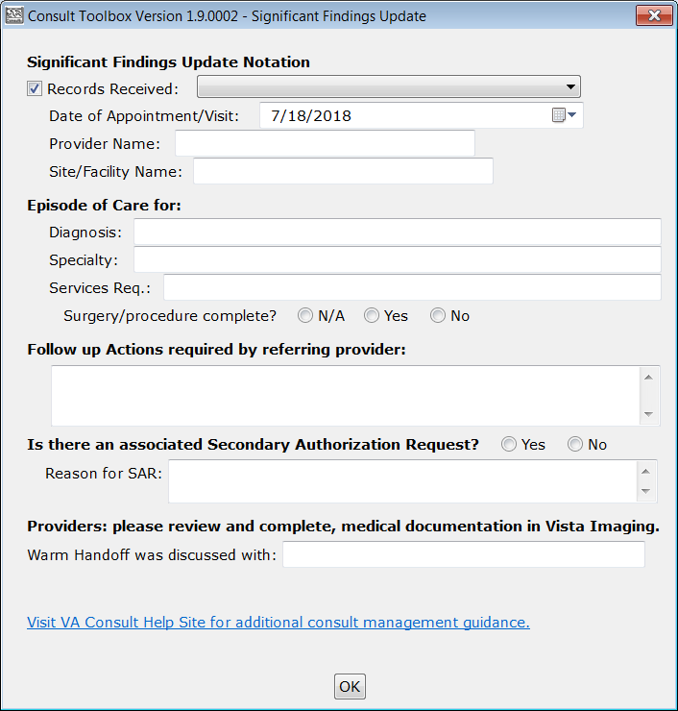

* **Significant Findings Update Notation**
* **Records Received**
* **Date of Appointment/Visit**
* **Provider Name**
* **Site/Facility Name**
* **Episode of Care for:**
* **Diagnosis**
* **Specialty:**
* **Services Req.**
* **Surgery/procedure complete?**
* **Follow up Actions required by referring provider:**
* **Is there an associated Secondary Authorization Request (SAR)?**
* **Reason for SAR**
* **Providers: please review and complete, medical documentation in VistA Imaging.**
* **Warm handoff was discussed with:**

### Administrative Closure

After three attempts to obtain records, a consult may be administratively closed. This will record that the consult was closed without records, which may be tracked.

Figure : Administratively Close

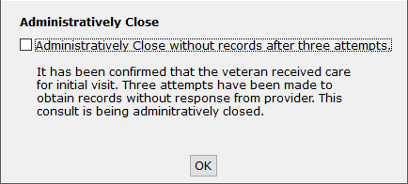

**Administratively Close without records after three attempts** — It has been confirmed that the Veteran received care for initial visit. Three attempts have been made to obtain records without response from provider. This consult is being administratively closed.

# Using the Software

The Consult Toolbox provides user functionality in the following consult windows:

* **Receiving Consult Activities** — this can be configured to open automatically.
* **Discontinuing Consult** — this can be configured to open automatically.
* **Forwarding Consult** – right-click in comment required, only for forwarding to community care.
* **Adding Comment to Consult** — this can be configured to open automatically.
* **Significant Findings** – right-click required, may be used when needing to convey a message to the ordering provider, though a progress note should also be present with more detail.
* **Administratively Close Consult** — right-click in comment required, only for instances where community care was completed, but records are unavailable.

1. For a list of Health Factors that are used in Consult Toolbox, please refer to Appendix A: Consult Factor Types and Definitions within this document.

## Receiving Consult Activities

Clinicians and/or delegated administrative staff receive View Alert in CPRS/ of VA order/consult notification. When a provider receives a pending consult, review should include determination of whether the consult is appropriate to be scheduled, and optionally, additional direction can be given to the scheduler.

The Receiving Consult Activities tab is used by any clinic in the VA facility that receives a consult. This clinic may be an internal VA clinic or a community care clinic.

To receive consult, follow the steps listed below:

1. From the **Action** menu, select **Consult Tracking…**, and then select **Receive**. The **Receive Routine Consult Options** window opens.

Figure : Receive Routine Consult Options Window



1. From the **Receive Routine Consult Options** section, select the consult option. **Accept consult, schedule routine appointment** is the default process. The appointment will be scheduled according to routine scheduling instructions. Routine scheduling means that the Veteran will be given the next open appointment. If that appointment is over 30 days, Veteran’s Choice Program (VCP) will be an option available to the Veteran.
2. Subsequent radio buttons under the receive consult options provide guidance to keep the Veteran in-house and overbook.
3. If the Veteran is an established patient, then select the **Established pt., please schedule then discontinue consult** check box.
4. If an appointment is not available for the Veteran within 30 days, select **Forward to Community Care Office** or **Discuss with clinical staff** from the **If no appt. slot is available within 30 days:** drop-down menu.
5. From the **Additional comments and instructions** section, select the options that best apply to this consult.
6. If the consult is high risk and needs to be tracked and extra scheduling efforts, select the **High Risk Consult-Extra scheduling effort warranted** check box from the **Consults should be marked “High Risk” for track and extra scheduling effort** section.
7. If the consult is high risk, from the **Extra scheduling effort** select the option that to specify what additional effort you would like. In addition to the selection of options, you may type in other instructions.
8. From the **For Schedulers Who Receives Consults:** section, select if a call was made to the Veteran or if a letter was sent was sent to the Veteran.
9. Select the **Letter Sent by Certified Mail** check box if a certified letter was sent to the Veteran.
10. Click **OK**.

## Discontinuing Consult

When discontinuing a consult, a reason that meets central office criteria must be entered to document the reason for discontinuation. Right clicking the text area will bring up the list of approved reasons. Additional comments may be made as well. There are two tabs, one relates to in-house consults, and one for Community Care consults.

### Discontinuing In-house Consult

1. From the **Action** menu, select **Consult Tracking…**, and then select **Discontinue**. The **General Discontinuation Comments** window opens.

Figure : General Discontinuation Comments



1. Select the **General Discontinuation Comments** tab.
2. From the **Discontinue consult requires one of the following reasons** section, select the reason why the consult is being discontinued.
3. In the **Explanation to sender of other reason to DC** text box, enter an explanation on why the consult is being discontinued.
4. Click **OK**.

### Discontinuing Community Care Consult

1. From the **Action** menu, select **Consult Tracking…**, and then select **Discontinue**. The **General Discontinuation Comments** window opens.

Figure : Comm Care Discontinuation Comments

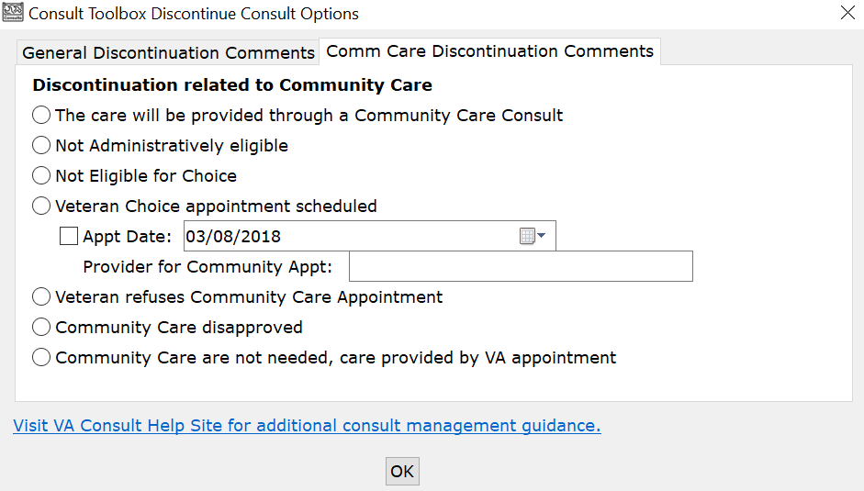

1. Select the **Comm Care Discontinuation Comments** tab.
2. From the **Discontinuation related to Community Care** section, select the Community Care discontinuation reason.

* — care will be provided by Community Care. ***USE WITH CAUTION***. This is saying that this consult is being discontinued and a Community Care consult ***will be*** issued for this service. Typically, a consult should only be discontinued when a non-VA care appointment has been scheduled (See next option)

1. This **The care will be provided through a Community Care Consult** option would be selected when an Interfacility Consult is sent from Site A to Site B, enabling Choice. The consult would then be discontinued by staff at Site B with instructions to order a Community Care consult at site A.
2. The calendar widget contains a default date, so you must check the box to indicate that the date in the box is the appointment date for it to be recorded.
3. Click **OK**.

## Forwarding Consult

At present forwarding only supports forwarding to Community Care.

1. This tab will be used by staff in internal VA clinics if the Veteran has opted in to receive care in the community.

To forward consult, follow the steps listed below:

1. From the **Action** menu, select **Consult Tracking…**, and then select **Forward**. The **Forward to Community Care Options** window opens.

Figure : Forward to Community Care Options



1. From the **Forward to Community Care Options** section, select the appropriate Community Care option.
2. Click **OK**.

## Adding Comment to Consult

There are many activities that can take place that should be documented in the medical record, as this is the official Veteran record, and needs to be tracked. The Consult Toolbox makes this quick and easy. The activities are divided into three user groups, and then from the group, specific activities can be documented. The three groups are:

* Scheduler Functions
* Community Care Functions (Non-VA)
* Clinical Review Options

### Scheduling Functions

The Scheduler Functions screen documents Consult Management for In-House Schedulers**.** The In-House Schedulers can document activity in three tabs:

* Calls and Letters
* Sched/Rescheduling Efforts
* Community Care Eligibility

#### Scheduling Calls and Letters

It is important to note that if a call results in a successfully scheduled appointment, these comments are not required. When an appointment is scheduled, it should be linked to the consult which will, in turn, annotate the consult and change the status to “Scheduled.”

The comments are intended for documentation of scheduling effort when there has not been an appointment scheduled, so that unsuccessful calls to the Veteran may be documented. In those cases, it should be recorded that the Veteran was called, and the attempt was unsuccessful. This includes the case where the Veteran is contacted, but they didn’t want to schedule the appointment at that time.

To schedule calls and letters, follow the steps listed below:

1. From the **Action** menu, select **Add Comment**. The **Add Comment to Consult** dialog box will display.

Figure : Add Comment to Consult Dialog Box

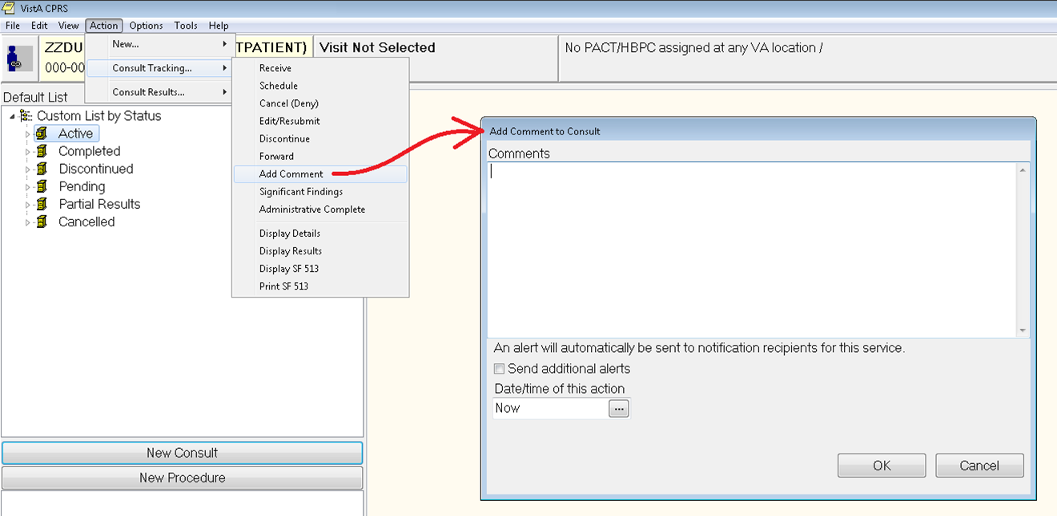

1. In the **Comments** field, right-click and then select **Scheduler Functions**. The **Scheduler Options** window opens with the **Calls and Letters** tab displayed.

Figure : Calls and Letters Tab



1. From the **Unsuccessful attempts to schedule Veteran** drop-down menu, select the best option.
2. From the **Unsuccessful attempts to schedule Veteran**, select if a first, second, or subsequent call to Veteran check box.
3. Select the **Letter Sent by Certified Mail** check box if you were unable to reach the Veteran and sent a certified letter.
4. From the **Additional results from scheduling attempt**, select the options you may wish to record to better document efforts. Not all clinics will have a need for all options.
5. If a scheduling effort fails after attempting to schedule an appointment by making two calls, sending a letter, and waiting two weeks, select the **Refer to clinical reviewer for disposition after unsuccessful scheduling effort** checkbox.
6. Business rules for certain low-risk consults may allow the scheduler to discontinue without clinician review, or in the case the provider previously reviewed the consult and determined that it may be discontinued after a failure to schedule after mandated effort or multiple missed appointments.
7. Click **View Consult History**. The **Viewing Consult History** dialog box displays.

Figure : Viewing Consult History

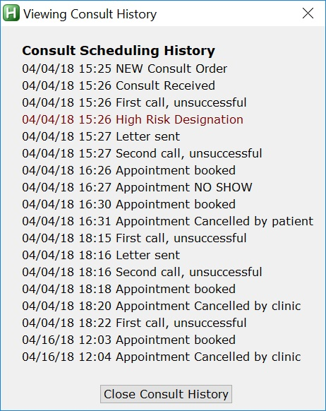

1. Click **Close Consult History**.
2. Click **OK**.

#### Scheduling and Rescheduling Efforts

Within this tab, these data fields track the number of missed appointments and/or the reason Veteran did not want appointment to be scheduled. It is important for in-house Schedulers to document these data fields to eliminate wait lists and decrease wait times for Veterans in need of care. Additionally, by documenting Veteran’s usage of private insurance and preference to seek care outside of the VA at their own expense, VA staff can track the utilization of VA benefits. IMPORTANT: appointments scheduled in VistA Scheduling and properly linked to an appointment will automatically update the consult, with both scheduling appointments and also when appointments are cancelled or the Veteran no-shows. **In those cases, there is no need to document missed appointments with the Toolbox.** First cancel-by-Veteran or no-show counts as a first missed appointment. Subsequent cancel-by Veteran or no-show counts as the second (or third+) missed appointment.

To schedule and rescheduling efforts, follow the steps listed below:

1. From the **Action** menu, select **Add Comment**. The **Add Comment to Consult** dialog box will display.

Figure : Add Comment to Consult Dialog Box



1. In the **Comments** field, right-click and then select **Scheduler Functions**. The **Scheduler Options** window opens with the **Calls and Letters** tab displayed.

Figure : Calls and Letters Tab



1. Select the **Sched/Rescheduling Efforts** tab.

Figure : Sched/Rescheduling Efforts Tab



1. From the **Missed appointments** select, select the best option.
2. From the **Second missed appointment** select, select the best option.
3. If a scheduling effort fails after attempting to schedule an appointment by making two calls, sending a letter, and waiting two weeks, select the **Refer to clinical reviewer for disposition after unsuccessful scheduling effort** checkbox.
4. Business rules for certain low-risk consults may allow the scheduler to discontinue without clinician review, or in the case the provider previously reviewed the consult and determined that it may be discontinued after a failure to schedule after mandated effort or multiple missed appointments.
5. Click **OK**.

#### Community Care Eligibility

This data field documents a Veteran’s decision to opt-in or out of the Veteran’s Choice Program (VCP) if there is insufficient access within a VA clinic.

1. With the transition to single booking business processes, a Veteran will be added to the COMMUNITY CARE only when he or she opts in to the VCP. Refer to Scheduling Directive.

To schedule and rescheduling efforts, follow the steps listed below:

1. From the **Action** menu, select **Add Comment**. The **Add Comment to Consult** dialog box will display.

Figure : Add Comment to Consult Dialog Box



1. In the **Comments** field, right-click and then select **Scheduler Functions**. The **Scheduler Options** window opens with the **Calls and Letters** tab displayed.

Figure : Calls and Letters Tab



1. Select the **Community Care Eligibility** tab.

Figure : Community Care Eligibility Tab



1. Select the **Spoke with Veteran/caregiver**, **Veteran Opt-OUT for Community Care**, **Veteran Opt-IN for Community Care (Reason required)**, **Veteran instructed Contractor/Community Care will call them for scheduling**, or **Veteran provided Community Care Fact Sheet** check box.
2. If the Veteran opted in for Community Care, select the reason from the options listed.
3. If the Veteran faces an unusual or excessive travel burden, select the option from the list and enter an explanation in the **Explain** field.
4. From the **EWL Follow up** section, select the options to document a follow-up to a Veteran while on the wait list.
5. Click **OK**.

### Community Care Functions

Community Care functions document activities that have taken place with the Veterans Choice or other Community Care programs that are provided by the VA.

When compiling pertinent medical documentation for upload to the TPA Portal, it is highly recommended that the Referral Documentation Tool (REFDOC) be used. REFDOC is an innovative solution that extracts from the Veteran’s electronic medical record and records into PDF format for exchange with community care providers. REFDOC improves the timeliness of medical record transfers by allowing VA staff to quickly extract Veterans’ health information from Veterans Health Information Systems and Technology Architecture (VistA), Computerized Patient Record System (CPRS), and Corporate Data Warehouse (CDW) and compile it into a PDF package that can be easily shared with community providers.

When sending medical documents directly to the community provider, the use of Virtru Pro is recommended. Virtru Pro is an innovative solution that provides VA a secure method of exchanging information with community providers using encrypted e-mail. It is one of many innovative solutions VA is implementing to enhance care coordination for Veterans and to become a better partner for community providers. For more information on REFDOC and Virtru Pro, visit the [VHA CC Solutions Site](https://vaww.vha.vaco.portal.va.gov/DUSHCC/DC/DO/CI/S/default.aspx).

#### MSA Eligibility Verification

To set the Community Care MSA Eligibility Verification options, follow the steps listed below:

1. From the **Action** menu, select **Add Comment**. The **Add Comment to Consult** dialog box will display.

Figure : Add Comment to Consult Dialog Box



1. In the **Comments** field, right-click and then select **Community Care Functions**. The **Community Care Functions** window opens with the **MSA Elig. Verification** tab displayed.

Figure : Community Care Functions Window: MSA Elig. Verification Tab



1. Select the **Administrative Eligibility verified**, **Basic Choice Eligibility Verified**, **Specific Choice Eligibility Verified**, **Presumed eligible, HEC Update Pending**, or **Unable to Verify Eligibility** check box that best describes the Community Care MSA eligibility verification.

|  |  |
| --- | --- |
| Triangle with an exclamation point (!) inside to indicate caution for the reader to take special notice of critical information. | **CAUTION:** Staff must contact local enrollment and eligibility office before proceeding. |

1. Once you have contacted local enrollment and eligibility, select the best option from the **Delegation of Authority Medical Services List Reviewed** section.

* Clinical review required
* Does not require clinical review

1. Information under Document Administrative Screening is populated and provides care coordination information about this Veteran. Additional details are in Community Care Document Administrative Screening and Clinical Triage tool section.
2. Click **OK**.

##### Community Care (CC) Document Administrative Screening

The Screening/Triage tool enables staff to assess the Veteran’s care coordination needs in the community. The tool consists of an administrative screening and clinical triage sections. While the administrative section may be completed by any integrated team staff member (MSA/PSA, Social Worker, RN), the clinical section may be only completed by clinical staff. The administrative section consists of questions about the urgency of the Veteran’s care request, the requested services in the consult, and the corresponding Veteran CAN (Care Assessment Need) score, accessible through VHA Support Service Center (VSSC). Based on the answers in this section, the tool will determine whether a clinical assessment will be necessary. If so, the tool will prompt the user to input the name of the RN responsible for completing the clinical section and send an alert.

Figure : MSA Elig. Verification Tab: Document Administrative Screening Section

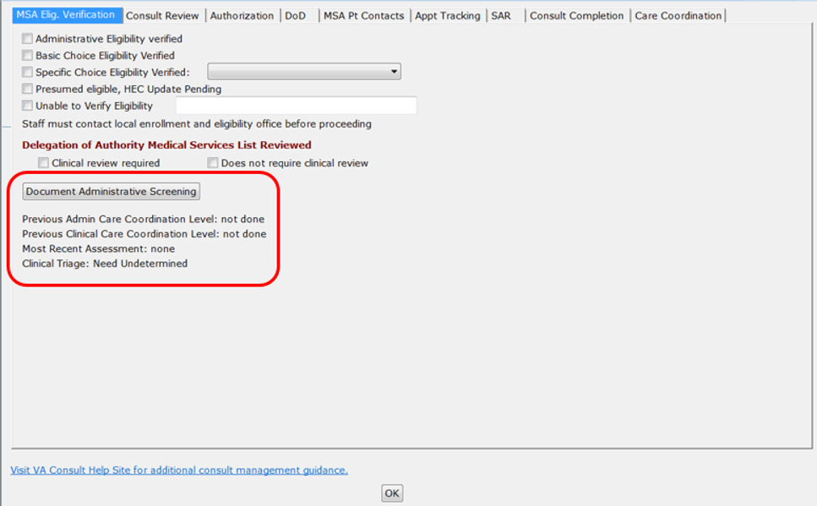

1. From the **MSA Elig. Verification** tab, click **Document Administrative Screening**. The **Administrative Screening (for use by community care staff only)** window opens.

Figure : Administrative Screening (for use by community care staff only) Window



1. If clinical review has already been performed, it will show. If administrative screening has been performed on this consult previously, it will be indicated as such in the administrative screening section.
2. Select the **Yes** or **No** radio button for the **From the Are you a clinical staff member** question.
3. Select the **Yes** or **No** radio button if there is an urgency to have an appointment in the next 48 hours.
4. From the **Does the consult specify any of the following complex conditions or services?** drop-down menu, select if the consult specifies any complex conditions or services.
5. Either a complex or basic service may be selected from the drop-down menus but not both, if both are selected the first selection will be reset to “None of the above”.
6. From the **Does the consult specify any of the following basic services?** drop-down menu, select the applicable service.
7. From the **CAN Score** section, select appropriate selection with regards to the CAN Score.
8. If the **Current Coord Level Assessment** is not **Basic**, input the name of the clinical staff member responsible for completing the clinical triage portion of the tool in the **Name of scheduling staff member you will alert:** field. This is not shown for clinical staff.

Figure : Name of scheduling staff member you will alert: Field

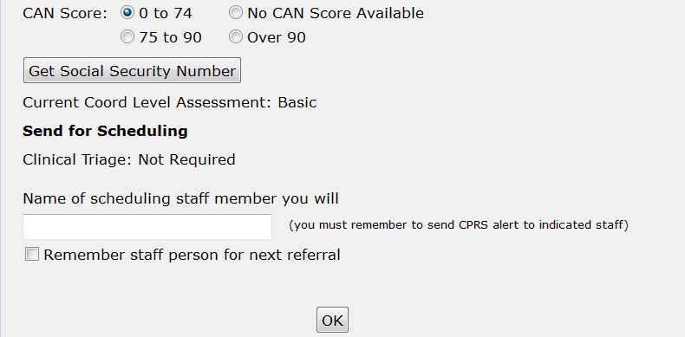

1. Select the **Remember staff person for next referral** check box if you would like Consult Toolbox to remember your selection for the next referral.
2. This does not send the actual alert, the user is responsible for sending the alert using the **Send additional alerts** button on the comment screen:
3. Click **OK**. The Document Administrative Screening information will populate on the MSA Elig. Verification tab.

Figure : Document Administrative Screening Populated

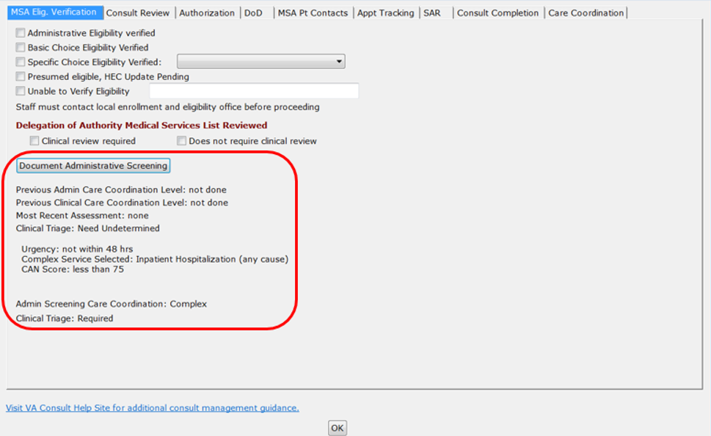

#### Consult Review

To set the CC Consult Review options, follow the steps listed below:

1. From the **Action** menu, select **Add Comment**. The **Add Comment to Consult** dialog box will display.

Figure : Add Comment to Consult Dialog Box



1. In the **Comments** field, right-click and then select **Community Care Functions**. The **Community Care Functions** window opens.
2. Select the **Consult Review** tab.

Figure : Consult Review Tab



1. From the **Community Care Clinical Review** section, select if the request was approved or disapproved. If the request was approved, you will need to select the CC Program from the drop-down. If the request was not approved, you will need to select the reason from the drop-down.
2. If the Provider authorizes discontinuation after failure of mandated scheduling effort without further clinical review, select **May discontinue if Veteran cancels/no-shows or fails to respond to mandated scheduling effort** check box and select the number of times from the drop-down menu.
3. From the **Scheduling to be performed by** section, select if the scheduling will be done by either VA staff, Health Net, or TriWest.
4. Click **OK**.

##### Clinical Triage

If the level of care coordination determined in the administrative screening section is not basic, the administrative staff member will alert a clinical care coordinator to complete the clinical triage section below. The clinical section consists of questions regarding the Veteran’s comorbidities, social factors, and need for assistance with Activities of Daily Living (ADLs). There is also a drop-down menu which the clinical care coordinator may fill out to override the results of the tool using clinical evidence-based judgment.

1. If clinical triage has already been performed, it will show. Also, if care coordination has already been assigned by Administrative screening that will also show.

To complete the clinical triage, follow the steps listed below:

1. From the **Action** menu, select **Add Comment**. The **Add Comment to Consult** dialog box will display.

Figure : Add Comment to Consult Dialog Box



1. In the **Comments** field, right-click and then select **Community Care Functions**. The **Community Care Functions** window opens.
2. Select the **CC Consult Review** tab.

Figure : Consult Review Tab



1. Click the **Document Clinical Triage** button. The **Clinical Triage for Care Coordination** window opens.

Figure : Clinical Triage for Care Coordination



1. The Clinical Triage tool will recommend a care coordination level once the following items are populated.
2. From the **Veteran Comorbidities:** section, select **No** or **Yes** if the Veteran will require additional care coordination/support during this episode of care due to two or more comorbidities.
3. From the **Psychosocial Factors:** section, select **No** or **Yes** if the if the Veteran will require additional care coordination/support during this episode of care due to any psychosocial factors (e.g. Dementia, Depression, Homelessness, Lack of Caregiver Support).
4. From the **ADL Support:** section, select **No** or **Yes** if the Veteran will require ADL support.
5. The tool will automatically calculate a level of care coordination based on the answers in is the steps above. The coordination level will display in the **New Clinical Triage Coordination Level** section.

Figure : New Clinical Triage Coordination Level

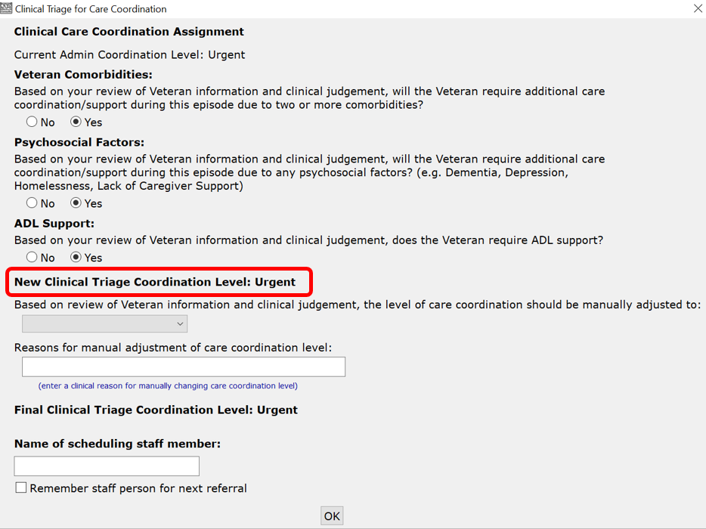

1. Based on clinical judgment, the clinical care coordinator may override the automated result. If manual adjustment is required for the level of care coordination, select the revised level in the drop-down menu along with the reason for adjustment in the text box.
2. The **Final Clinical Triage Coordination Level:** auto-populates based on the completion of clinical triage questions or manual override.
3. In the **Name of scheduling staff member:** field, enter the name of the staff member.
4. Click **OK**. The screening/triage tool will populate a comment in the body of the consult detailing the level of care coordination, directions for proceeding with care coordination, and a list of potential care coordination services required by the Veteran. The comment will also provide guidance on the frequency of contact and need for warm handoff.

Figure : Comment Added to Consult

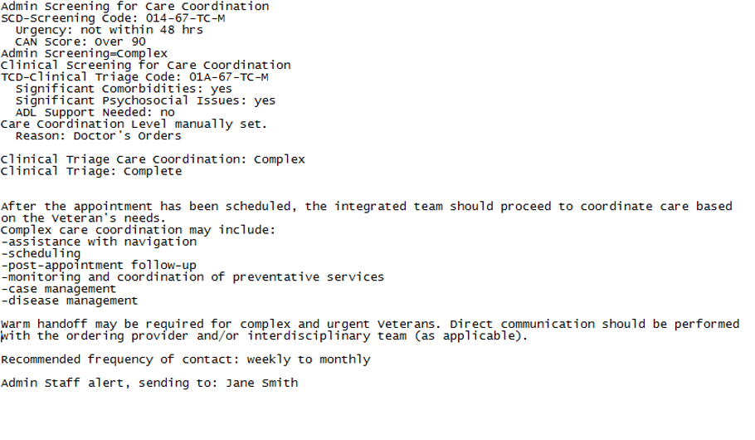

#### **Authorization**

This information documented within the Authorization tab populates from data contained in the consult if present, but will not be added to the consult again unless changes and the checkbox is checked shown and described below. **Authorization instructions to be included with Referral.**

1. From the **Action** menu, select **Add Comment**. The **Add Comment to Consult** dialog box will display.

Figure : Add Comment to Consult Dialog Box



1. In the **Comments** field, right-click and then select **Community Care Functions**. The **Community Care Functions** window opens.
2. Select the **Authorization** tab.

Figure : Authorization Tab



1. The Speciality section of the window will populate from data contained in the consult if present, but will not be added to the consult again unless changes and the check box is checked.
2. From the **SEOC** drop-down menu, select one of the authorized service listed or enter the desired SEOC.
3. Select the **Include Standard Authorization Language** check box to insert the language that displays in the box.
4. Select the **Add the following to authorization** check box to allow for additional pertinent information.
5. Any additional treatments, procedures or referrals must have a Secondary Authorization Request submitted.
6. Select the **Community Care Manager** check box to include the name of the Community Care manager, and add a contact number.
7. Once the referral is ready for Authorization Form, select the **Send to HSRM for Referral** check box from the **Upon completion of this section:**.
8. Click **OK**.

#### **DoD**

This information documented within the Authorization tab populates from data contained in the consult if present, but will not be added to the consult again unless changes and the checkbox is checked shown and described below. **Authorization instructions to be included with Referral.**

1. From the **Action** menu, select **Add Comment**. The **Add Comment to Consult** dialog box will display.

Figure : Add Comment to Consult Dialog Box



1. In the **Comments** field, right-click and then select **Community Care Functions**. The **Community Care Functions** window opens.
2. Select the **DoD** tab. The **DoD** tab displays.

Figure : DoD Tab



1. From the **DoD Urgency** section, select
2. From the **Exceptions List Determination** section, select

#### MSA Pt Contacts

1. From the **Action** menu, select **Add Comment**. The **Add Comment to Consult** dialog box will display.

Figure : Add Comment to Consult Dialog Box



1. In the **Comments** field, right-click and then select **Community Care Functions**. The **Community Care Functions** window opens.
2. Select the **MSA Pt Contacts** tab.

Figure : MSA Pt Contacts Tab



1. From the **Unsuccessful Attempts to Schedule Veteran** section, select the best option.
2. From the **Additional Results from Attempt** section, select the best option.
3. From the **Veteran Contacted** section, select the best option.
4. From the **Veteran’s Choice Participation Preference** section, select the best option.
5. From the **Veteran’s Preferred Provider Information** section, select the best option.
6. Select the **Refer to clinical reviewer for disposition after unsuccessful scheduling effort** check box if after failing to schedule an appointment by making two calls, sending a letter, and waiting two weeks, this option refers the consult to a clinician to review and disposition.
7. Click **OK**.

#### Appt Tracking

1. From the **Action** menu, select **Add Comment**. The **Add Comment to Consult** dialog box will display.

Figure : Add Comment to Consult Dialog Box



1. In the **Comments** field, right-click and then select **Community Care Functions**. The **Community Care Functions** window opens.
2. Select the **Appt Tracking** tab.

Figure : Appt Tracking Tab



1. Select the best option for appointment tracking.
2. From the **Actual/Approved Provider Information** section, enter the name of the actual provider with whom the Veteran has an appointment.
3. From the **Returned from Health Net/TriWest (Select reason)** section, select the reason why the referral was returned from Health Net or TriWest with the corresponding rationale.
4. From the **Disposition of returned referral** drop-down menu, select the status of the referral.
5. From the **Missed Community Care Appointment** **care still Active/Pending** drop-down menu, select the reason for the missed appointment.
6. From the **Community Care Appointment occurred (Waiting for records)** drop-down menu, select the appointment that occurred without receipt of medical records.
7. Click **OK**.

#### Secondary Authorization Request

1. From the **Action** menu, select **Add Comment**. The **Add Comment to Consult** dialog box will display.

Figure : Add Comment to Consult Dialog Box



1. In the **Comments** field, right-click and then select **Community Care Functions**. The **Community Care Functions** window opens.
2. Select the **SAR** tab.

Figure : SAR Tab



1. From the **Secondary Authorization Request (SAR)** section, select the SAR urgency from the drop-down menu.
2. From the **Same Provider authorization and/or Additional Services or Visits Requested** section, select the best options.
3. From the **Actions Taken** section, select if the SAR was approved or disapproved.
4. Select the **Include Standard SAR Authorization Language** check box to include the additional authorization language for the secondary authorization request.
5. Click **OK**.

#### Consult Completion

1. From the **Action** menu, select **Add Comment**. The **Add Comment to Consult** dialog box will display.

Figure : Add Comment to Consult Dialog Box



1. In the **Comments** field, right-click and then select **Community Care Functions**. The **Community Care Functions** window opens.
2. Select the **Consult Completion** tab.

Figure : Consult Completion Tab



1. From the **Completion Efforts** section, select the options for completion.
2. Click **OK**.

#### Care Coordination

This tab allows entry of comments that occur during case management contacts. It also allows documentation of an alert being sent to another staff member, or a warm handoff.

1. The comment doesn’t send the alert, the user must still identify the person to send the alert to, and do so in CPRS.
2. From the **Action** menu, select **Add Comment**. The **Add Comment to Consult** dialog box will display.

Figure : Add Comment to Consult Dialog Box



1. In the **Comments** field, right-click and then select **Community Care Functions**. The **Community Care Functions** window opens.
2. Select the **Care Coordination** tab.

Figure : Care Coordination Tab



1. From **Time spent on care coordination** section, enter the time spent on care coordination.
2. In the **Care Coordination Notation** section, enter any care coordination activities.
3. In the **Performed warm handoff of this consult to:** field, enter the name of the recipient of the warm hand off.
4. In the **Sent alert to:** field, enter the name of the individual that an alert is being sent to
5. Click **OK**.

### Setting Clinical Review Options

Provider functions allow providers reviewing records to document the results of their review or other actions that need to be documented.

To document the results of your review or other actions that need to be documented, follow the steps listed below:

1. From the **Action** menu, select **Add Comment**. The **Add Comment to Consult** dialog box will display.

Figure : Add Comment to Consult Dialog Box



1. In the **Comments** field, right-click and then select **Clinical Review Options**. The **Clinical Review Options** window opens.

Figure : Clinical Review Options



1. From the **Instructions for scheduling or rescheduling** section, select the instruction for consult.
2. From the **Urgent requests booked > days require chart review and attestation that non-urgent scheduling is appropriate** section, select the **Currently scheduled appointment clinically appropriate** check box for STAT consults that are scheduled more than seven days from the create date, but after clinical review, are felt to be appropriately timed.
3. From the **Additional comments and instructions** section, select the appropriate option(s).
4. From the **Consults may be marked “High Risk” for tracking and extra scheduling effort** section, select the **High Risk Consult—Extra scheduling effort warranted** check box if the consult needs extra scheduling.
5. Click **OK**.

## Significant Findings – Community Care Action Needed Notation

Use this feature to flag significant findings for the ordering provider (e.g., test results are available). This box is used with the significant findings CPRS comment to alert the ordering provider of results received especially in the case where a follow up action is needed on the part of the VA provider.

To update significant findings for the ordering provider, follow the steps listed below:

1. From the **Action** menu, select **Consult Tracking…**, and then select **Significant Findings**. The **Significant Findings Update** window will display.

Figure : Significant Findings Update



1. In the **Significant Findings Update Notation** section, enter the required information for each field.
2. In the **Episode of Care for:** section, enter the diagnosis, specialty, services required, and if the surgery/procedure is complete.
3. In the **Follow up Actions required by referring provider:** section, enter the required actions.
4. Select if a Secondary Authorization Request is needed. If a Secondary Authorization Request is needed, enter the reason in the **Reason for SAR** field.
5. Enter the name of the individual that the warm handoff was discussed with in the **Warm Handoff discussed with:** field.
6. Click **OK**.

## Administratively Close Consult

After the attempts to obtain records, a consult may be administratively closed. This will record that the consult was closed without records, which may be tracked.

To administratively close a consult, follow the steps listed below:

1. From the **Action** menu, select **Consult Tracking…**, and then select **Administrative Complete**. The **Administratively Close** dialog box will display.

Figure : Administratively Close Dialog Box



1. Select the **Administratively Close without records after three attempts.** check box to administratively close the consult. Selecting this check box confirms that that the Veteran received care for initial visit. Three attempts have been made to obtain records without response from provider.
2. Click **OK**.

# Troubleshooting

If Consult Toolbox is not running in CPRS, the user will need to verify that Consult Toolbox in running in the system tray.

## National Service Desk and Organizational Contacts

For issues related to the Consult Toolbox that cannot be resolved by this manual or the site administrator, please contact the National Service Desk at 855-NSD-HELP (673-4357).

# Acronyms and Abbreviations

|  |  |
| --- | --- |
| Acronym | Definition |
| CAC | Clinical Application Coordinators |
| CCAD | Community Care Agile Development |
| CDW | Corporate Data Warehouse |
| CID | Clinically Indicated Date |
| CPRS | Computerized Patient Record System |
| HEC | Health Eligibility Center |
| NSD | National Service Desk |
| OI&T | Office of Information and Technology |
| PCP | Primary Care Physician |
| SAR | Secondary Authorization Request |
| SEOC | Standardized Episode of Care |
| VA | Department of Veterans Affairs |
| VDL | VA Software Document Library |
| VistA | Veterans Health Information Systems and Technology Architecture |

1. Appendix A: Consult Factor Types and Definitions

| Consult Factor Type | Consult Factor Text |
| --- | --- |
| A1- | Accept consult, schedule within 1 week, (OK to overbook). |
| A1M | Accept consult, schedule within 1 month (OK to overbook). |
| A2- | Accept consult, schedule within 2 weeks, (OK to overbook). |
| AAR | Approved as Requested (SAR) |
| AB- | Address bad or no address on file, unable to send letter. |
| AC- | Accept consult, schedule routine appointment. |
| ACC | Admin Screening Care Coordination |
| ACF | Community care approved under Choice First. |
| ACN | Administratively closed without records |
| ADT | Accept Consult, schedule on specific date, ok to overbook |
| AEV | Administrative Eligibility verified. |
| AFU | AFU-Total Authorized Units/Visits: |
| ALR | Alert Sent to: nameofperson |
| ANV | Community care approved under NVCC. |
| APP | DoD Consult Approved |
| AS- | Accept consult, see scheduling order for scheduling instructions. |
| C1- | First call to veteran, unable to schedule. |
| C1C | Comm Care First Call to Veteran |
| C2- | Second call to veteran, unable to schedule. |
| C2C | Comm Care Second Call to Veteran |
| C3- | Third or additional call to veteran, unable to schedule. |
| C3C | Comm Care Third or subseq. Call to Veteran |
| CA- | Clinically Appropriate to wait for the scheduled appointment. |
| CAD | Vista cancellation for Administrative reason |
| CAN | Administratively closed without records |
| CAP | Community care approved for specified program. |
| CAP | Community care approved for specified program. |
| CB- | Patient contacted but pt will call back to schedule later. |
| CBD | CBD-Care authorization expires on |
| CCA | A community care appt has been scheduled. |
| CCC | Community care appointment was cancelled by patient. |
| CCC | Community care appointment was cancelled by patient. |
| CCC | Community Care Cancelled by Patient |
| CCD | Community Care Appointment Date: |
| CCH | Community Care Appt Scheduling to be handled by: |
| CCL | Vista Cancelled by Clinic |
| CCM | Care Coordination was manually Set |
| CCO | Care Coordination Time Spent: |
| CCP | Community Care Cancelled by Clinic |
| CCP | Community care appointment was cancelled by provider. |
| CCR | Community Care Provider: |
| CCR | Community Care Provider: |
| CCS | Community Care Appointment has been Scheduled |
| CEV | Choice Eligibilty Verified. |
| CEV | Choice Eligibilty Verified. |
| CHD | Contractor Not Used: Community Provider declines Choice Network participation. |
| CHD | CHD-Community Provider declines Choice Network participation |
| CHN | Network Provider not accepting Choice patients |
| CHN | Contractor Not Used: Network Provider not accepting Choice, patients. |
| CHU | Contractor Not Used: Choice Provider unable to schedule within CID (Urgency) |
| CHU | Choice Provider unable to schedule within CID (Urgency) |
| CHV | Veteran declined appointment due to date/time/distance |
| CHV | Contractor Not Used: Veteran declined appointment due to date/time/distance. |
| CID | Prior CID=FactorData after Edit/Resubmit |
| CLA | Admin Screening Care Coordination: |
| CLC | Clinical Triage Care Coordination: |
| CLV | Care Coordination Level |
| CMP | Completed Consult |
| CNC | Consult Cancelled |
| CNS | Community Care Veteran No Show for Appt |
| CNS | Community care appointment was no-show. |
| COC | Community care appointment occurred, per patient (awaiting confirmation). |
| COI | Veteran OPT-IN for choice. |
| COI | Veteran OPT-IN for choice. |
| COO | Veteran OPT-OUT for choice. |
| COO | Veteran OPT-OUT for choice. |
| COR | Community care appointment occurred, records received. |
| COT | Community care appointment occurred, per TPA portal, awaiting records. |
| CP1 | Cancelled by patient, first missed appointment. |
| CP2 | Cancelled by patient, second missed appointment. |
| CPP | Consult ready for CPP Referral |
| CPT | Vista Cancelled by Patient |
| CTC | Clinical Triage: Complete |
| CTN | Clinical Triage: Not Required |
| CTR | Clinical Triage: Required |
| CU- | Patient states that they have an appointment scheduled through the Veterans Choice program, however there is no documentation to this effect in the consult. |
| DCP | DoD Consult Present |
| DDO | DoD Date of Svc Outside of Approved EOC |
| DEC | Patient declines/refuses-does not want appointment. Please submit new consult if patient agrees to care. |
| DIS | Disapprove Reason |
| DLA | Delegation of Auth.: Administrative |
| DLC | Delegation of Auth.: Clinical |
| DNC | Non DoD consult present |
| DNP | DoD Consult Not Present |
| DNY | Request for community care is disapproved. |
| DOK | OK to leave appt. details with |
| DP- | Scheduling plans discussed with ordering provider. |
| DSC | Discontinued Consult |
| DSF | Documents sent via fax to community care provider. |
| DSO | Disassociate Report |
| DTE | DTE-Veteran's Day/Date Preference: |
| DU- | Document Uploaded to TPA Portal. |
| DUP | Duplicate Request. |
| E90 | No appointment within 90 days |
| EDC | Established patient, follow-up appointment has been scheduled. |
| EEF | Extra Scheduling Effort requested |
| ENV | Environmental factors: |
| ERS | Edit/Resubmit |
| EST | Established patient, please schedule appt. then DC consult. |
| EWL | On EWL or awaiting CHOICE. Pt added to Electronic Wait List, no available appt w/in 90 days. |
| EXP | Patient has expired. |
| FDX | FDX-Veteran has an active Third Party Release on file. |
| FSE | Failed mandated scheduling effort (multiple missed/cancelled appts. or patient did not respond to mandated scheduling effort). Consult discontinued, per VA consult management policy. Please submit a new request if care is still desired and patient agrees to receiving care. |
| FUV | Follow up call made to provider/vendor to check on status. |
| FWD | FORWARDED FROM |
| FWR | FWD TO REMOTE SERVICE |
| G30 | Appointment is greater than 30 days from PID |
| GEO | Geographical challenges: |
| GVM | Guideline Method used for approval |
| HEC | Presumed eligible, HEC Update Pending. |
| HR- | High risk consult, please continue to attempt scheduling even after mandatory scheduling effort. |
| HSR | Consult ready for HSRM Referral |
| INC | INCOMPLETE RPT |
| INF | INF-Veteran informed of eligibility, referral and approval. |
| INF | Veteran informed of eligibility, referral and approval. |
| L1- | L1-Unable to schedule letter sent by mail to Veteran. |
| L1- | Letter sent to patient. |
| L1C | Community Care unable to contact letter sent by Mail. |
| L1C | Community Care scheduling letter sent by regular US Mail. |
| LC- | LC-Above letter sent by Certified Mail. |
| LC- | Certified letter sent to patient regarding scheduling. |
| LCC | Community Care scheduling letter sent by Certified Mail. |
| LCC | Community Care unable to contact letter sent by Certified Mail. |
| LM- | Left message on voice mail. |
| LMF | Left message with family member. |
| MA3 | Third or more missed appointments. |
| MAT | Approval for maternity care |
| ME- | May discontinue if patient cancels/no-shows twice or fails to respond to mandated scheduling effort. |
| MED | Medical condition: |
| MFU | Follow up call made to veteran while on wait list to confirm wait list status. |
| MLS | Willing to travel up to (miles): |
| MOK | Mailing Address Confirmed |
| MOK | MOK-OK to leave appt. details on voice mail. |
| MSC | Scheduled but not from VistA |
| NAE | Not administratively eligible. |
| NAP | DoD Consult Not Approved |
| NEL | Patient does not meet eligibility requiresments. |
| NN- | Care is no longer needed. |
| NNA | NEW NOTE ADDED |
| NOS | VA facility does not provide the required service |
| NR- | No records received after three attempts. |
| NS1 | No Show, first missed appointment. |
| NS2 | No Show, second missed appointment. |
| NSH | Vista Patient was a No-Show |
| NVA | The care will be provided through a Community Care Consult. |
| NVD | Non-VA Care disapproved. |
| NVD | Community Care disapproved. |
| NVN | Community Care not needed, care provided by VA appointment. |
| NVN | Non-VA care not needed, care provided by VA appointment. |
| NXC | Not eligible for Choice. |
| ODC | Other discontinuation reason: |
| OTH | Vista cancellation for other reason |
| OTP | OTP-Veteran OK to see other than Preferred Provider |
| P30 | Procedure scheduled greater than 30 days from PID |
| PB- | Phone contact number bad/incorrect or disconnected. |
| PFP | PFP-Veteran's Preferred Provider |
| PKT | Referral Packet mailed to veteran. |
| PRA | Community Care Provider has accepted referral |
| PRC | Procedure(s) Approved for Community Care |
| PRD | Procedure Requested |
| PRF | Preferred notification method: |
| PRQ | Provider requires records to review prior to scheduling. |
| PVT | Patient declines/refuses-going to private provider outside VA care. |
| R1- | First attempt to get records from community care. |
| R1- | First attempt to get records from community care. |
| R2- | Second attempt to get records from community care. |
| R3- | Third attempt to get records from community care. |
| R3- | 3rd attempt to get records from community care |
| R3- | 3rd attempt to get records from community care. |
| RAC | Refer to clinical reviewer for administrative completion. |
| RCF | RCF-Received 7332 signed ROI Form, ready to schedule. |
| REC | Receive Consult |
| REF | Veteran declined/refused-does not want appointment. |
| REF | Veteran refuses Community Care appointment. |
| REF | Patient refuses non-VA appointment. |
| REL | REL-Veteran has a signed ROI for 7332 conditions on file. |
| RFC | Patient declined/refused community care. |
| RFV | Referral returned from community care vendor. |
| ROI | Mailed 7332 ROI Form to enable this referral to proceed. |
| RP- | Referred to provider for disposition after unsuccessful scheduling effort. |
| RP- | Referred to provider for disposition after unsuccessful scheduling effort. |
| RP- | Referred to provider for disposition after unsuccessful scheduling effort. |
| RR- | Records from community care provider received. |
| RRH | Records Received via: |
| S1M | Schedule/reschedule within 1 month, ok to overbook. |
| S1W | Schedule/reschedule within 1 week, ok to overbook. |
| S2W | Schedule/reschedule within 2 weeks, ok to overbook. |
| SCC | This Referral is for a Service Connected Condition. |
| SCD | Administrative Care Coordination Screening |
| SCR | Service/Care Approved for Community Care |
| SDC | Patient still desires care. |
| SDT | Accept Consult, schedule on specific date, ok to overbook |
| SDX | SDX-Veteran has dx requiring 7332 ROI. |
| SEV | Specific Choice Eligibility: |
| SIG | SIG FINDING UPDATE |
| SIM | Nature or simplicity of service (UEXB): |
| SOR | Schedule/reschedule-see Scheduling Order for instructions. |
| SPA | This referral is for Special Authority. |
| SPC | Specialty Approved for Community Care |
| SR- | Schedule/reschedule routine appointment. |
| SSC | SSC-Veteran prefers to self schedule appointment. |
| SSP | Subspecialty Approved for Community Care |
| SUR | SAR Urgency: |
| SV- | Spoke with veteran/care giver. |
| SVC | Services requested. |
| TCC | Clinical Triage Care Coordination |
| TCD | Clinical Care Coordination Triage |
| TFR | Timeframe for Episode of Care Approved |
| TIM | TIM-Veteran's Time Preference: Any |
| TOS | Type of service |
| UCH | Prior Urgency after Edit/Resubmit |
| UNV | Unable to Verify Eligibility |
| UXB | Unusual or Excessive travel burden |
| VCA | Vista cancellation for other reason |
| VCL | On EWL or awaiting CHOICE. Pt added to VCL. |
| VCL | Veteran placed on VCL |
| VDS | Returned Referral Disposition |
| VSC | Vista Scheduled Appointment |
| VTC | VTC-Veteran contacted Community Care. |
| WHO | This consult was discussed with and handed off to |
| XXC | Some other status change reason |

1. Appendix B: Community Care Appointment Tracking – VA Scheduling Appointment

The outlined options are presently being tested for Community Care taking responsibility for scheduling Community Care appointments.

1. This screenshot applies only to the version being tested in Fargo and Alaska VAMCs.

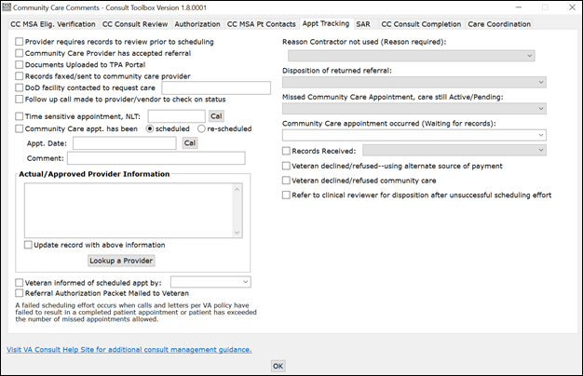

**Reason Contractor not used** **(Reason required):** — Community Care appointment was not arranged through the vendor. Reason for not using contractor is required.

